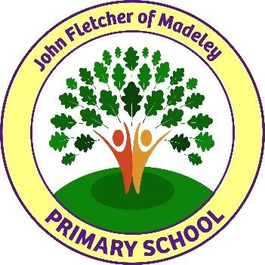

John Fletcher of Madeley Primary School
“Whatever you do, work at it with all your heart”, Colossians 3:23

TIMESCALES

Opportunity to visit school | Upon Request
Application form to be returned to school: | Tuesday 11 June 2024 @ 12 noon
Interviews | Wednesday 19 June 2024

If you wish to arrange to visit the school, please contact us on 01952 388188.

If you have not been contacted by Wednesday 12 June, we thank you for your application but regret that you have not been successful on this occasion.

Appointments made are subject to an Enhanced DBS (formerly CRB) Disclosure.

Thank you for your interest in the post and we look forward to receiving your application.

