Teaching Assistant
ROLE INFORMATION PACK

Department | Whole School
Place of Work | Severndale Academy (Monkmoor)
Application deadline | 08 October 2026 Midday
Potential interview date | TBC
Enquiries to | recruitment.severndale@lct.education
Applications to | recruitment.severndale@lct.education

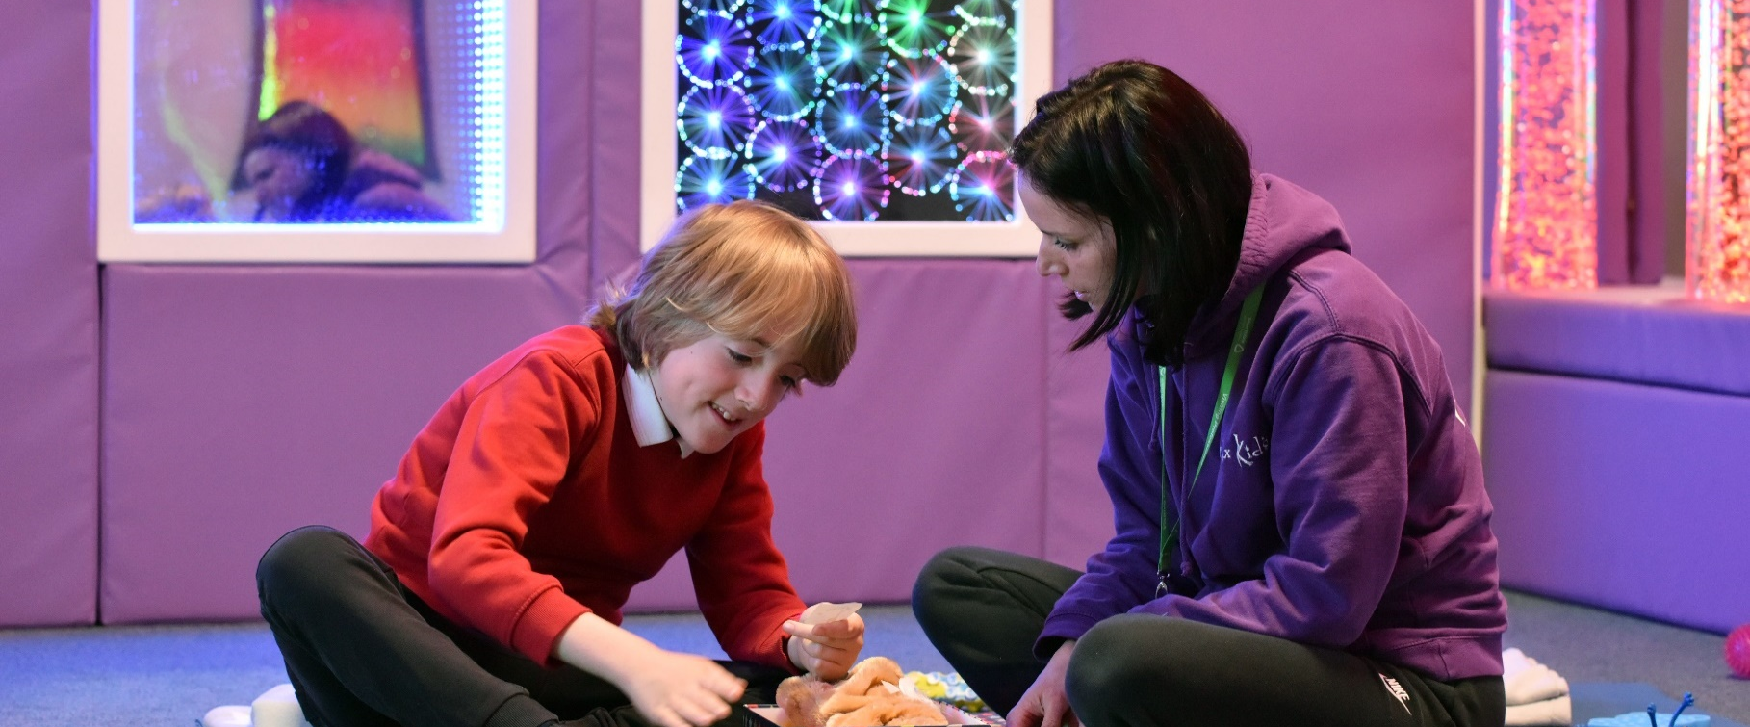

Introduction and welcome

Thank you for your interest in the Teaching Assistant role at the Learning Community Trust, based at Severndale Academy.

We are looking for a motivated and ambitious Teaching Assistant to join the Severndale Team. This role is a vital part of our journey to develop, improve and support our education services across the trust. As a teaching assistant, you will assist in interactive learning, promotion of personal development and ensure that the curriculum is achieved for the best possible outcome for the student within the academy. Under the instruction and guidance of teaching staff, health staff and other professionals, to undertake educational activities and attend to the education, personal and social needs of the students in order to support their learning and development, and to ensure their safety.

It is vital that the potential candidate has a can-do attitude and is committed to their own personal development in an ever-changing landscape of education. I am confident that the successful candidate will find tremendous support within the Learning Community Trust, where collaboration, innovation and continuous improvement are fundamental principles – ensuring that we offer the best service and experience to our young people in Telford and Shropshire.

Best wishes,
Lucy Lee
Executive Principal


About the trust
The Learning Community Trust is a multi-academy trust which spans education for children and young people from the age of 2 years old through to 16 years old, and up to 25 years old in our specialist settings. We have an excellent reputation both regionally and nationally and are proud to place our young people, staff and families at the heart of everything we do. We want our young people to thrive, enjoy school, and understand the importance of respect for others.

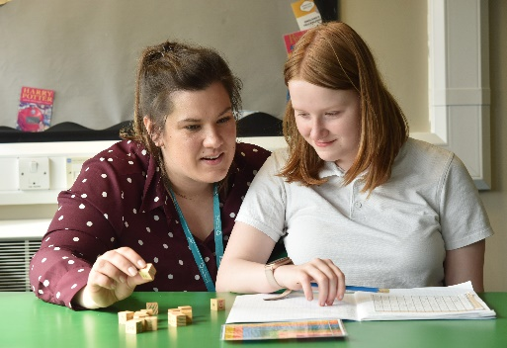
The Learning Community Trust exists because we have a commitment and passion for providing great academies for our communities. We acknowledge and celebrate the distinctness and individuality of each academy’s community; we celebrate equality, diversity, inclusivity and individuality because we believe that we have far more in common than that which divides us.

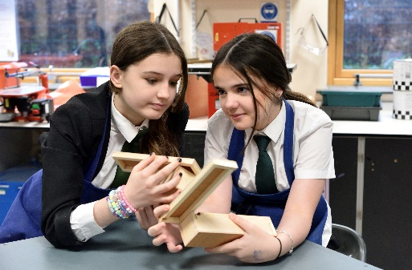
The trust academies span across the education sector, with primaries, secondaries, and specialist academies. This means we are responsible for thousands of young people and staff across our campuses; we take that responsibility very seriously. Each academy is individual and has its own distinctive ethos. However, we all share the same Learning Community Trust value, to support all our young people to ensure that – regardless of their background or starting point – they can achieve exceptional educational outcomes.

Our absolute focus is to provide the highest quality of education and pastoral care in our academies, developing compassionate, caring, humble and inspirational young people who can thrive within an ever-changing global community.

Staff members across our trust benefit from a broad spectrum of training opportunities, including nationally recognised development programs, all tailored to support the specific needs of our academies and their personnel. Whether you are beginning your journey in education or are an experienced leader, we are here to ensure you reach your fullest potential.
 | Our Mission  Delivering an inclusive, compelling and transformative education that empowers young people, both in the classroom and beyond, preparing them for the rapidly changing world ahead.

Our Vision
Developing compassionate, resilient and inspirational young people who can thrive within an ever-changing global community.

Our Values
A trust with heart |  | Successful young people | Never leave a child behind | Learning for all
Thriving community |  | Respect for all | Together we are stronger | Coping with the challenges of life


About Severndale Academy
Severndale Academy is a large special school which is part of the Learning Community Trust, a multi-academy trust working across Shropshire and Telford.

Our provision is split across three sites, including our main Monkmoor site, our satellite provision working within the Mary Webb mainstream secondary school and also our 16-25 provision based at Shrewsbury College called Futures. Please take some time to look through the various parts of the website for more information.

Our children and young people are aged 2.5 to 25 and have a range of learning difficulties. These include moderate, severe, complex and profound learning difficulties, those with autism, complex medical conditions and physical and mobility difficulties. A number of our young people present behavioural difficulties arising from their condition; many have communication difficulties.

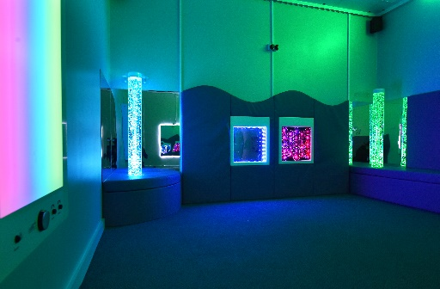
Our curriculum after the Foundation Stage (EYFS to Year 2) is arranged into Pathways 1, 2 and 3 to enable us to further tailor the curriculum to the strengths and needs of our learners. Please see our Curriculum page for further information.

Our vision is to ensure that the needs of all of our young people are ‘truly met’ and that we ensure pupils leave Severndale being as independent as they can be and are also ready to access ‘life beyond the school’. We focus on developing quality interactions, relationships and supporting positive communication, as well as providing high-quality learning experiences in a dynamic, creative, enjoyable and safe environment.

In essence... enabling communication, independence, and enjoyment for life.



Teaching Assistant
ROLE PROFILE

Overview

The main purpose of this post is to effectively provide teaching assistance to our students, ensuring
that the direction of the teaching staff is carryout and implement agreed work, care and support
programmes with individuals or groups. The successful candidate will be self-motivated and strive to
inspire and achieve the very best outcomes.

The Teaching Assistant will be responsible for:

Student Assistance
- Attend to students personal needs, and assist with the development and implementation of Individual Education, Behaviour and Personal Care programmes
- Supervise and support students, ensuring their safety and access to learning
- Establish constructive relationships with students and interact with them according to their individual needs
- Promote the inclusion and acceptance of all students
- Encourage students to interact and work co-operatively with others, and engage in learning activities
- Within the context of teacher-led planning set challenging and demanding expectations for students and promote self-esteem and independence
- Provide feedback to students in relation to progress and achievement under the guidance of the teacher

Teacher Assistance
- Assist with the planning of learning activities
- Use strategies in liaison with the teacher to support students to achieve learning goals
- Prepare the classroom as directed for lessons and clear afterwards. Assist with the display of students work
- Ensure the timely and accurate design, preparation and use of specialist equipment, resources and materials
- Monitor students responses to learning activities and accurately record achievement/progress as directed
- Provide detailed and regular feedback to teachers on pupils achievement, progress and problems
- Maintain records as requested
- Administer routine tests, invigilate exams and undertake routine marking of students work, accurately recording achievement and progress
- Promote good student behaviour, dealing with challenging behaviour in line with established policy and individual plans and encourage students to take responsibility for their own behaviour
- Provide general clerical and administrative support

Other Duties
- Support students understanding through use of appropriate communication
- Undertake structured and agreed learning activities and teaching programmes, adjusting activities according to student responses
- Support students in using ICT and develop students competence and independence in its use
- Prepare, maintain and use equipment/resources required to meet the lesson plans and relevant learning activities and assist students in their use
- Assist with the supervision of students out of lesson times, including before and after school and at lunchtimes
- Accompany teaching staff and students, as appropriate on visits, trips and out of school activities and supervise small groups of students on specific educational visits

Person specification
QUALIFICATIONS AND EXPERIENCE
- NVQ Level 2 Teaching Assistant or equivalent
- GCSE’s grades 9-4 (A*-C) in English and Maths
- NVQ Level 3 or above in a Teaching Assistant qualification or equivalent (desirable)
- Relevant experience working in a School
- Experience of working in a special school with children with Special educational needs. (desirable)
- Some experience of classroom administration support

SKILLS AND KNOWLEDGE
- Good knowledge of school based education
- Team Teach, Makaton, Moving and Handlings (desirable)
- Motivated
- Punctual
- Ability to relate well to children, staff and parents
- Work on own initiative
- Flexible approach to working environment
- Ability to meet the physical demands of the post
- Ability to bring to the role, initiative, enthusiasm and commitment
- Undertaken training in Restrictive Physical Prevention (Restraint) (Desirable)

Important
The Learning Community Trust is committed to safeguarding and promoting the welfare of Children and young people. All post holders are subject to an enhanced DBS check (including a check on the children’s barred list) for the successful applicant. References will be checked following the Learning Community Trust recruitment and selection process. We are committed to equality and diversity and follow the Safer Recruitment practices as set out in the Statutory Guidance - Keeping Children Safe in Education.

For more information regarding our schools commitment to safeguarding, please see our website for our school policies - https://severndaleacademy.co.uk/our-school/policies/

Role details

Department | Whole School
Place of work | Severndale Academy
Reporting to | Class Teacher
Tenure | Permanent
Hours | Term Time + 5 PD days , 32.5 hours per week
Salary | Scale 3, SP5-SP6: From £13.70 an hour (£19,880 pa)

