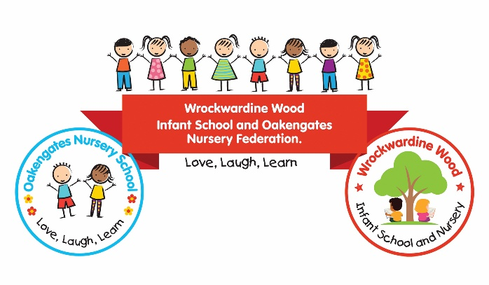

Love, Laugh, Learn
Resourcefulness, Reciprocity (Teamwork), Reflectiveness, Resilience

The Governing Board is seeking to appoint a friendly, enthusiastic and highly organised Administrative Assistant to join our dedicated team.

Post Title | Administrative Assistant
Scale | National Joint Council (NJC) Scale 3
Hours | 18 hours per week Term Time  Working pattern to be discussed at interview
Contract | Fixed-Term Contract

Join our team!
Are you organised, approachable and keen to make a difference to the lives of children and families?
Wrockwardine Wood Infant School & Nursery is looking for a motivated and reliable Administrative Assistant to support the smooth day-to-day running of our school. Working closely with the School Business Manager and senior leaders, you will play an important role in providing an efficient, welcoming and professional service to our school community.
This is a varied role, offering the opportunity to contribute to a range of administrative and organisational activities, including school communications, financial administration, procurement and the management of pupil and school information.

What will the role involve?
- Administrative support: Provide efficient support to the school office, responding to enquiries and preparing correspondence, documents, reports and returns.
- Reception and communication: Act as a friendly and professional first point of contact for parents, carers, visitors and external agencies.
- Finance and resources: Assist with routine financial administration, purchasing, procurement and the management of school resources.
- ICT and data management: Maintain accurate records and use school systems, including Bromcom and Sonar, to support effective administration and information management.
- Organisation: Support the organisation of school trips, events and activities, alongside providing administrative support to senior leaders and the Governing Board.
- Safeguarding and confidentiality: Handle sensitive information appropriately and follow school policies and procedures to help keep children safe.

What are we looking for?
The successful candidate will:
- Have strong organisational skills and the ability to manage competing priorities.
- Have good literacy, numeracy and IT skills, with confidence using electronic systems and databases.
- Communicate effectively and build positive relationships with children, families, colleagues and external professionals.
- Be able to use initiative, work independently and contribute positively as part of a team.
- Demonstrate professionalism, discretion and a commitment to confidentiality.
- Be flexible, adaptable and able to remain calm in a busy working environment.
- Share our commitment to safeguarding, inclusion and the wellbeing of every child.

Previous experience in an administrative role is essential. Experience of working in a school, using school management systems or undertaking financial administration would be an advantage.

Why join us?
Our motto, Love, Laugh, Learn, reflects our commitment to creating a caring, inclusive and supportive environment where children and adults can thrive.
You will join a dedicated team where your contribution is valued and where you can play an important part in supporting the learning, development and wellbeing of our children and families.

How to apply
Please read the job description and person specification carefully before completing the application form. Applicants should submit a completed application form and a covering letter explaining how their qualifications, experience and personal qualities make them suitable for the role.
Please email your completed application form and covering letter to a2116@taw.org.uk
Please note that CVs will not be accepted.

Closing date: Friday 23 October 2026
Interview date: Monday 2 November 2026

Safeguarding
Wrockwardine Wood Infant School and Oakengates Nursery Federation is committed to safeguarding and promoting the welfare of children and expects all staff and volunteers to share this commitment.
Appointment will be subject to satisfactory pre-employment checks, including references, verification of identity and an enhanced Disclosure and Barring Service (DBS) check, including children's barred list information where applicable.
Online searches will be undertaken for shortlisted candidates as part of our safer recruitment procedures. We are committed to equality of opportunity and welcome applications from all suitably qualified candidates.

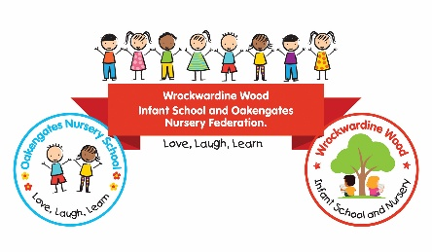
Wrockwardine Wood Infant School and Nursery is part of:
Wrockwardine Wood Infant School and Oakengates Nursery Federation.

