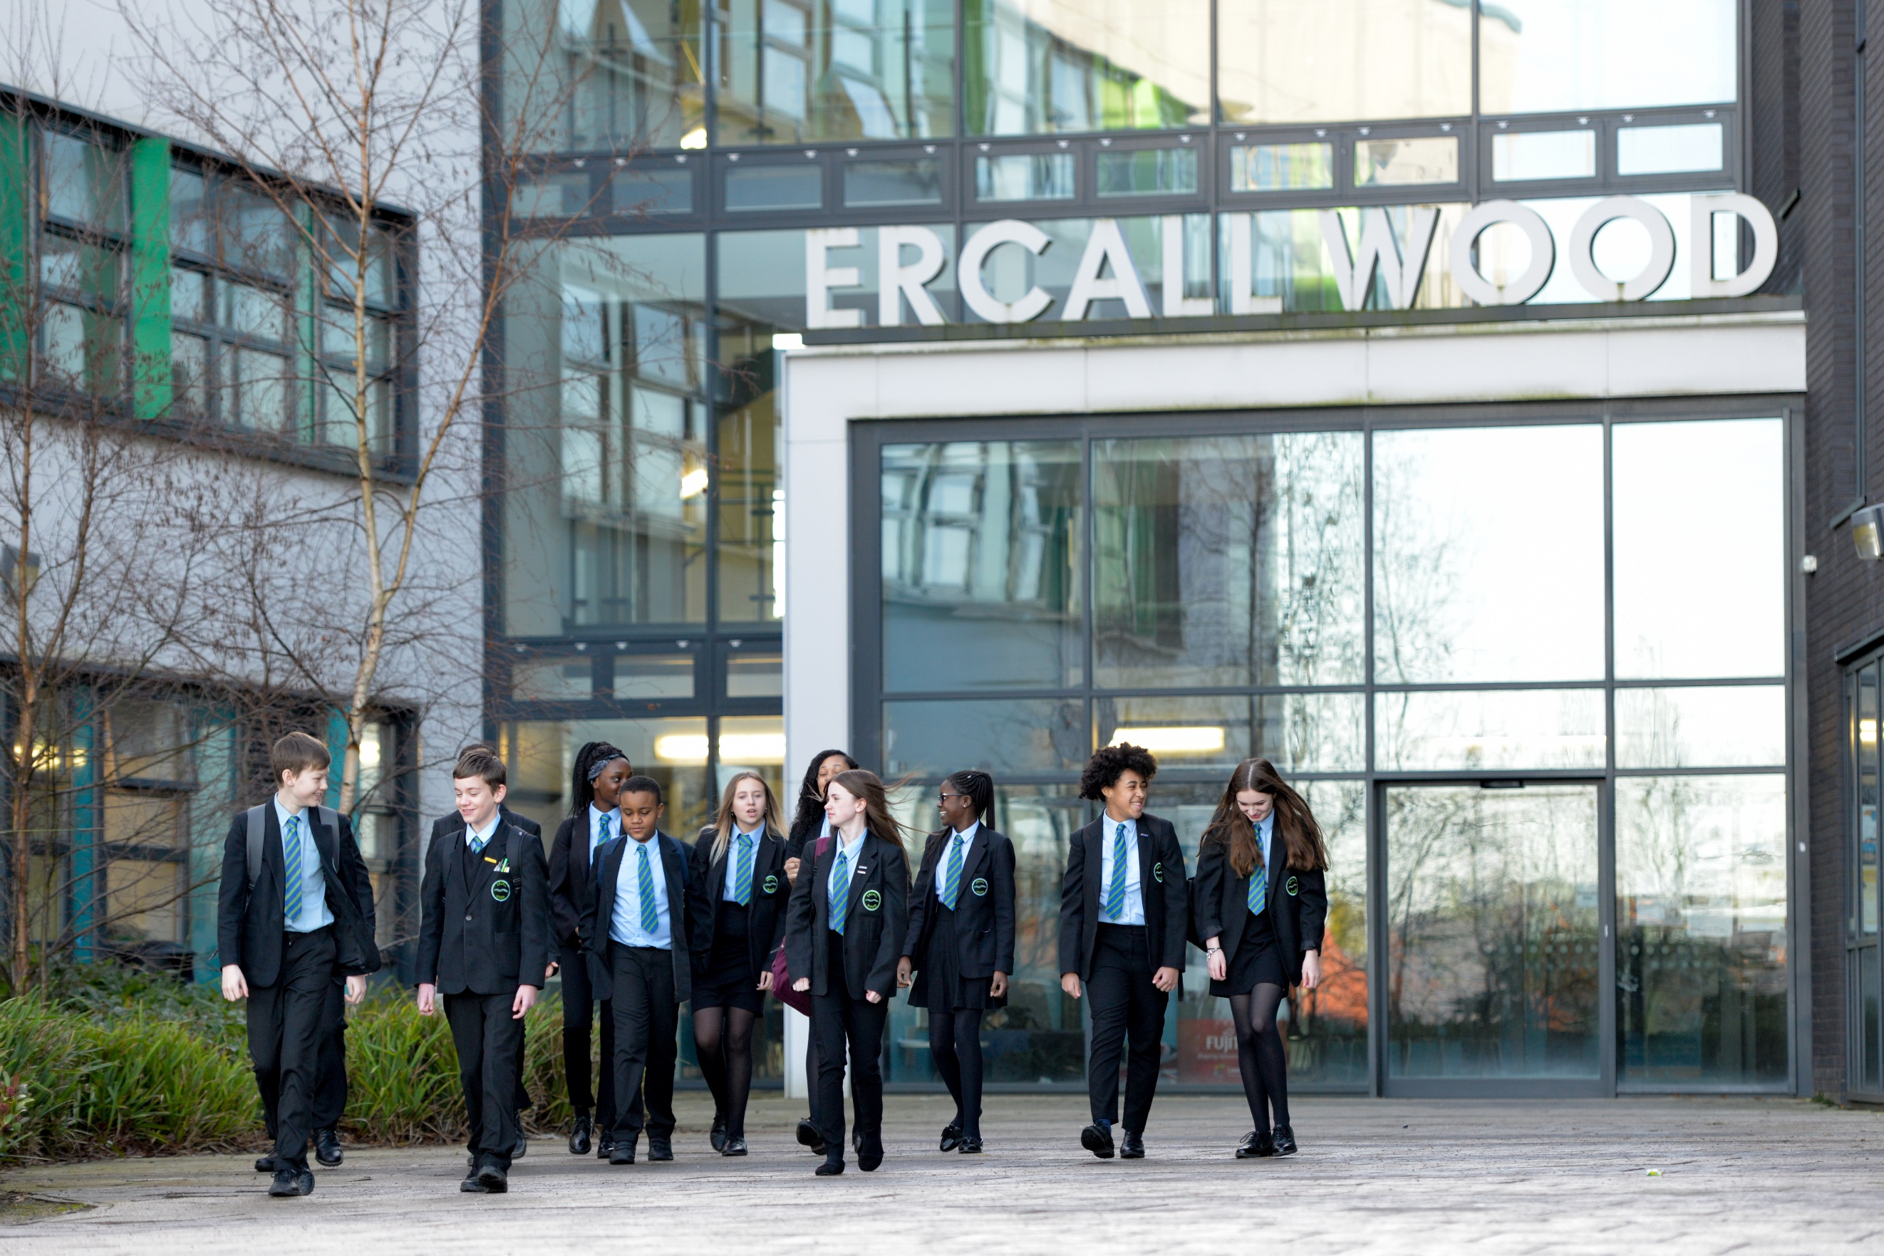
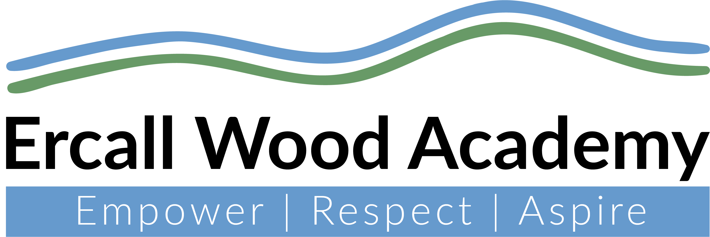
Cover Supervisor
Scale 5
37 hours Term Time
Permanent
Start date: As soon as possible




Welcome to Ercall Wood Academy

Ercall Wood Academy is on an exciting journey to excellence. We are built on the mantra of ‘doing the simple things exceptionally well’ through our traditional principle of expert teachers delivering a knowledge-rich curriculum.
Due to an increasing demand for admission places, you would be joining us to support the expansion of our curriculum.
The academy is a proud member of the highly successful Learning Community Trust and is situated in Wellington, Telford, which has excellent transport links with easy access to the M54 motorway.
This is a fantastic opportunity for you to be part of our drive to position Ercall Wood as a lead academy within the region and beyond.

Mr N Murphy
Principal

Vision
At Ercall Wood Academy, we promote and expect to have high aspirations for all our students. ‘All students’ truly means all students regardless of ability, gender, race and background.
We strive to empower our whole community with the knowledge, skills and habits necessary to make a positive difference to the community and the wider world.
Ercall Wood Academy is built on a culture of respect; respect for oneself, for others and for the environment. The academy has clear routines and responses to positive and negative behaviour, creating a safe, purposeful learning environment for all. We are traditional in our view that the teachers are the experts in the classroom and should be respected as such. Our teachers hold the key to unlocking the potential of our young people through the delivery of a high-quality curriculum built on key knowledge and skills.
We believe in the potential of all our students and their ability to achieve and be successful. We want our students to share the same high aspirations whether it is through academic success, sporting prowess or excellence in the arts. There are no limits to what can be achieved with hard work, resilience and determination.

Values

Empower: We strive to empower our whole community with the knowledge, skills and habits necessary to make a positive difference to the community and the wider world.
Respect: Excellence is built on a culture of respect. Respect for oneself, for others and for the environment.
Aspire: High aspirations by all, for all. ‘All’ truly means all regardless of ability, gender, race and background.



Teaching at Ercall Wood Academy

- Do you want to work in an academy where teachers are respected as the expert?

Teachers at Ercall Wood Academy are valued as the experts in the classroom. Underpinning all pedagogy is a strong understanding of the essential subject knowledge. We use Barak Rosenshine’s Principles of Instruction as a pedagogical guide and empower our departments to choose how best to deliver the curriculum to maximise students’ learning.
Departments meet weekly to review curriculum delivery and develop shared resources. This enables teachers to direct their time towards developing the instruction to explicitly meet the needs of their learners.
Professional Learning at Ercall Wood Academy
- Do you want to work in an academy that prioritises professional learning for staff?
Professional learning is at the heart of our drive to achieve excellence. The academy believes in embedding a culture of continuous professional learning for all and therefore we invest heavily in the development of our staff.
Every teacher has a dedicated, personal coaching session as part of our innovative coaching programme. This will enable teachers to develop their practice in a supportive environment through high quality feedback from their coach.
A dedicated professional learning hub in the academy provides a fully resourced space for staff to develop and share great practice.
There is a particular focus on providing those in the early stages of their careers with additional support and guidance needed to be expert teachers. We take our role in developing the next generation of teachers very seriously and have an extensive training programme in place.


Student culture at Ercall Wood Academy
- Do you want to work in an academy that has a very clear approach to addressing student behaviour?
We encourage a positive, calm and purposeful atmosphere where everyone feels safe, students can learn to the best of their abilities and everyone feels valued and treats others with respect. We empower young people to take responsibility for their behaviour and celebrate high standards in learning and behaviour. Any disruption to learning is discouraged and sanctioned through a straightforward, centralised sanction system. This allows teachers to deliver high quality lessons and fosters an environment where all members of the academy treat each other with respect.

Workload at Ercall Wood Academy
- Do you want to work in an academy that takes workload seriously?

To enable expert teachers to teach and leaders to lead, we have streamlined our systems and processes to ensure staff can focus on what matters most: our students.
We believe in ‘doing the simple things exceptionally well’. We have a clear understanding of the direction of the academy and what we need to do to get there. Excellence is achieved by building great habits over a sustained period of time.

For further information, please visit our website or email amy.goodall2@lct.education

