|  |  |  |
| --- | --- | --- |
|  | **Essential** | **Desirable** |
| **Qualifications** | * Qualified Teacher status * Education to degree level or higher * Evidence of continued professional development | * NPQEYL |
| **Safeguarding** | * Commitment to the protection and safeguarding of children. * Up-to-date knowledge of relevant safeguarding legislation and the ability to promote a culture of safeguarding across the school community. |  |
| **Experience** | * Experience of teaching in an EYFS setting * Experience of teacher in KS1 | * Experience of curriculum leadership in one or more areas |
| **Teaching and Learning** | * Clear understanding of what good quality teaching and learning looks like and strategies to develop this * Secure understanding of the requirements of the ELG and national curriculum * A secure understanding of the delivery of phonics and phonics assessments * Knowledge and understanding of a range of successful teaching and learning strategies to meet the needs of all pupils * Secure understanding of assessment strategies and the use of assessment to inform the next stages of learning * Clear understanding of the characteristics of successful behaviour management | * Experience in identifying and supporting vulnerable groups effectively |
| **Knowledge and Skills** | * Ability to communicate effectively, orally and in writing to a range of audiences; e.g. staff, pupils, governors, parents. * Knowledge of ways in which links with external agencies can be used to extend learning opportunities for pupils. * Excellent personal organisational skills. * Ability to prioritise workload and work to specific deadlines | * Ability to use data management systems. |
| **Personal Attributes** | * Understanding of and commitment to nurture and inclusion, and their impact upon learning. * High expectations for all pupils. * Ability to inspire, challenge, motivate and empower others. * Belief in and ability to foster a fair, open and supportive culture. * Self-motivation and a commitment to continued professional development. * A ‘can do attitude’ and an ability to solve issues as and when they arise | * Experience of working with other stakeholders and/or members of the community e.g. Friends/PTA association. |

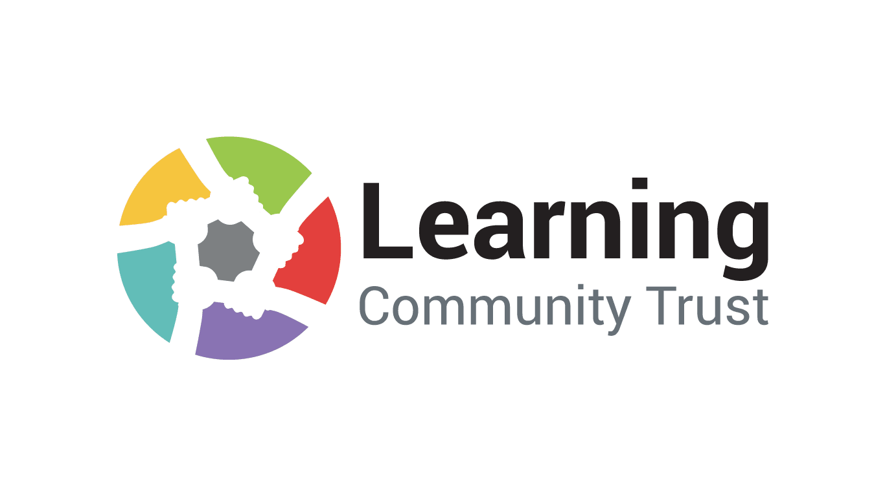 **Job Specification**