Madeley Nursery School



APPOINTMENT OF HEADTEACHER

From September 2025 Information for Applicants



Madeley Nursery School – Headship Appointment

Thank you for your interest in the post of Headteacher at our school. This post will be available from September 2025.
Please read the information contained in this pack carefully. It is designed to give you an overview of our school as well as to assist you in completing your application.
The contents of this pack are as follows:

- The Recruitment Advert
- Information about the post, training and support
- Information about the application process
- Information about Madeley Nursery School and it’s pedagogical approach
- The Job Description
- The Person Specification

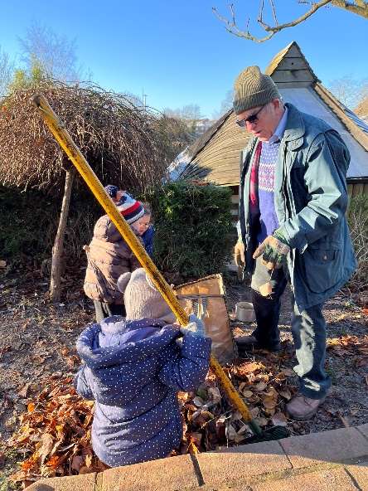
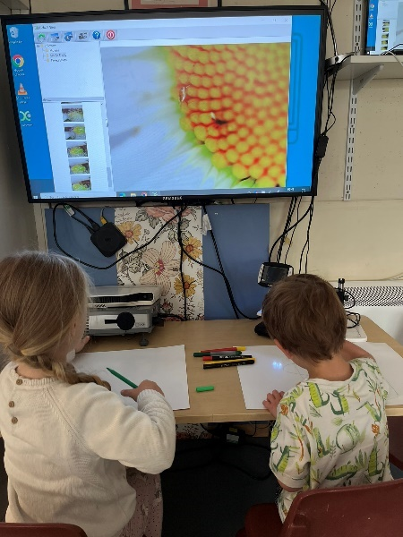
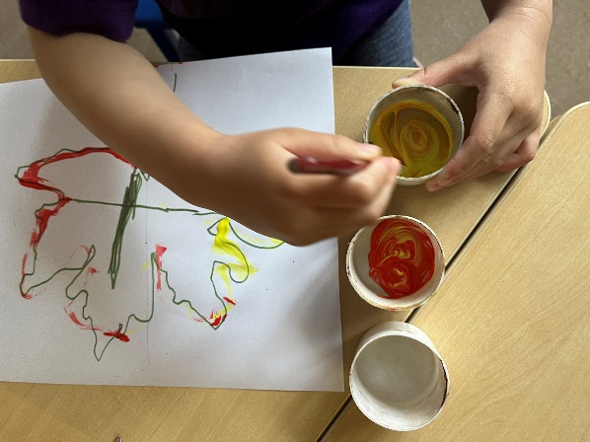

The Recruitment Advert

 | Madeley Nursery School  Bridle Road  Telford  TF7 5ET  01952 388210  madeley.nursery@taw.org.uk  www.madeleynurseryschool.co.uk

HEADTEACHER
Required from September 2025

Group 1 ISR L6 £56,316 – L12 £65,286 * TBC subject to updated STPC 2024
Due to the retirement of our current Headteacher, our Governing Body is seeking to appoint a visionary Headteacher and exceptional classroom teacher, inspired by the creative and ecological preschools and infant-toddler centres of Reggio Emilia. They should have a deep understanding of early education and possess effective leadership and management skills to take up the position in September 2025.
Madeley Nursery School is a small community school at the edge of the UNESCO world heritage site of the Ironbridge Gorge. This is a thriving community providing early education and care to children from 2 to 4 years old.
The post involves up to a 0.5 teaching commitment.
Ofsted has judged this beautiful school to be outstanding since 2007.
“Children get off to a great start to their education at Madeley Nursery School. Leaders are highly ambitious for all children. They offer an exciting child-centred, creative approach to learning for every child.” Ofsted 2023.


Visits to the school are warmly welcomed and can be arranged by contacting the School Administrator on 01952 388210 or alternatively by emailing madeley.nursery@taw.org.uk.

To Apply

All completed application forms and your response to the supplementary question should be returned to shirley.thompson@telford.gov.uk or Shirley Thompson, School Governance, Telford & Wrekin Council, 6A Darby House, Lawn Central, Telford, TF3 4JA
Sorry but CVs will not be accepted.
We are committed to equality, diversity and to safeguarding and promoting the welfare of children and young people. We expect all staff and volunteers to share in this commitment. Appointment to this post is subject to an enhanced Disclosure and Barring Service check as well as other pre-appointment checks outlined in Keeping Children Safe in Education (September 2024). This post also requires checks under the Childcare Disqualification Regulations and Childcare Act 2006.
We invite you to read our Child Protection and Safeguarding Policy and Safer Recruitment Policy before applying for this post, both of which are available on our school website.
Rehabilitation of offenders: This post is exempt from the Rehabilitation of Offenders Act 1974 and the amendments to the Exceptions Order 1975, 2013 and 2020. Which means that when applying for certain jobs and activities certain spent convictions and cautions are ‘protected’, so they do not need to be disclosed to employers, and if they are disclosed, employers cannot take them into account. Further information about filtering offences can be found in the DBS filtering guide. An online search will also be carried out as part of due diligence on all short-listed candidates.
Closing Date: Thursday 17th October – 12 noon
Shortlisting Date: Friday 18th October
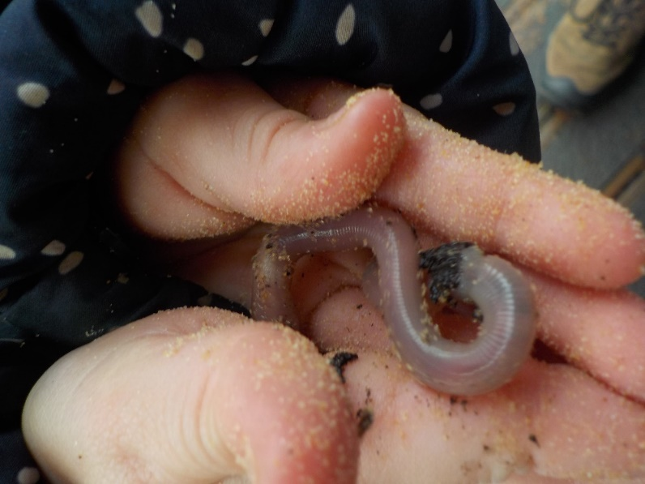
Interview Date: Wednesday 6th November and Thursday 7th November
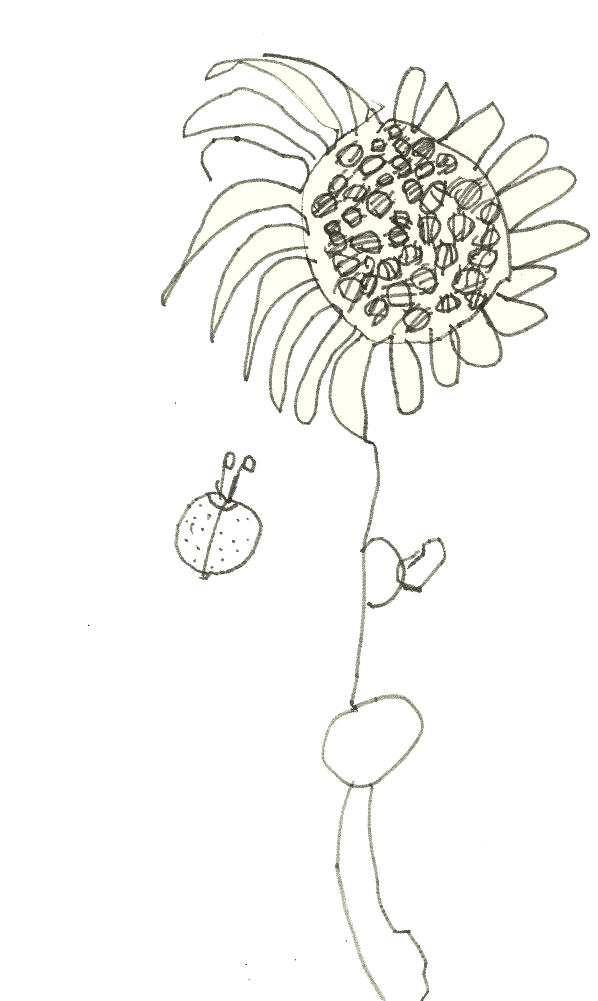

Letter from the school governors
Dear Applicant,

The school governors would like to wish
you a warm welcome to Madeley Nursery School and thank you for your interest in the position for Head Teacher.

Madeley Nursery School is a beacon of excellence in early childhood education. Renowned for its outstanding educational standards, the nursery has consistently received high praise from Ofsted, being rated as “Outstanding” in every inspection since 2007.

This accolade is a testament to the school’s unwavering commitment to providing a nurturing and stimulating environment for children.

The staﬀ at Madeley Nursery School are highly
qualified and passionate about early childhood
education. They are dedicated to creating a supportive and inclusive community where every child feels valued and respected.

The nursery’s educational philosophy is deeply inspired by the Reggio Emilia approach, which emphasises child-centred learning through exploration, creativity, play and research.
This approach is evident in the school’s beautifully
designed learning environments, which are
thoughtfully arranged daily to encourage curiosity
and discovery. It is equally evident in our educators who are reflective and multi-faceted in their approach to learning and teaching. During the day they are co-learners and collaborators with the children; they are researchers, documenting children’s progress in a meaningful way for future re-visiting and they also facilitate and react in real time to create a rich, stimulating environment to provoke curiosity and learning.

One of the standout features of Madeley Nursery School is its ecological curriculum, which integrates environmental education into daily learning experiences. Children are encouraged to develop a deep respect for nature through activities such as gardening, recycling, and exploring the natural world. This focus on sustainability not only enriches the children’s learning but also instils in them a sense of responsibility towards the environment.

The nursery’s commitment to research and innovation is another key aspect of its success. As a researching school, Madeley Nursery, prior to Covid, was actively involved in numerous national and international projects related to early years education. The Governor’s desire is that the school remains deeply committed to this. We are aware that this involvement ensures that the school remains at the forefront of educational best practices and continuously evolves to meet the needs of its children and their families.

Parental involvement is strongly encouraged at Madeley Nursery School, with numerous opportunities for parents to engage in their children’s learning journey. The school believes that a strong partnership between home and school is essential for the holistic development of each child. Regular workshops, parent-teacher meetings, and community events foster a sense of belonging and collaboration among families.
The nursery’s inclusive approach extends to its admissions policy, which offers flexible part- day sessions to suit different schedules. Additionally, the school supports children with special educational needs and ensures that all children have access to high-quality early education.

In summary, Madeley Nursery School is a shining example of excellence in early childhood education. Its child-centred, Reggio Emilia-inspired approach, combined with a strong ecological curriculum and a commitment to research and innovation, creates a rich and nurturing environment for young learners. The dedicated staﬀ, inclusive community, and strong parental involvement further enhance the school’s ability to provide an outstanding educational experience for every child.

The ideal headteacher for Madeley Nursery School should be a visionary leader with a deep understanding of early childhood education. The governors ideally are seeking a headteacher who is either a prominent figure or has the deep-routed desire and energy to develop themselves to be a prominent figure, in the field of early years education.

They should possess strong interpersonal skills, enabling them to build positive relationships with children, staﬀ, and parents. A commitment to continuous professional development and a passion for innovative teaching methods are essential.

The headteacher should also be an advocate for inclusive education, ensuring that every child has the opportunity to thrive. Additionally, they should have a proven track record of successful leadership and management, with the ability to inspire and motivate our dedicated team of educators here at Madeley Nursery School. The governors also require that any prospective head teacher is committed to and is passionate about the Reggio Emilia approach.
Helen Beale Chair of Governors


The Role
This is a varied, demanding and creative role with a real opportunity to work as part of a motivated and dynamic team. Every day is different, the breadth of the role is considerable. You will be working with others beyond the school, reflecting with colleagues to continually evolve practice, developing policy, working with Governors, engaging with families, managing the budget and delivering outstanding teaching as part of the team.
This post is a designated customer facing role under the fluency duty and requires a specified level of spoken English as stated in the person specification.

Training and Support
The successful candidate will be supported in this role, you will be joining a friendly, caring and supportive environment both within the school and the wider school – our Headteacher works within the South of Telford cluster of schools. The school works closely with the national professional network, Sightlines-Initiative.
We have a team of dedicated and skilled staff, a strong and supportive Governing Body, enthusiastic, friendly children and supportive, engaged parents in a caring community.
Our Governing Body and the Local Authority will work with you to identify and review your individual training and development needs. Support will be available to you via training, networking and advice meetings, the Local Authority, CPD and the cluster. Particular support is available for newly appointed Headteachers including school to school support and mentoring.

Application process
When completing the application form please refer to the contents of this Information Pack, include details of your experience and skills that are relevant to the requirements of the post and ensure that your personal statement shows how you meet the selection criteria for the post.
The Governors invite applicants to address in 500 words the following supplementary question in addition to the application form.
Reflect on this quotation from Tiziana Filippini a pedagogical adviser for Reggio Children with a background in psychology.
Tiziana collaborates with Reggio Children by publishing projects, consulting, and through participating in seminars and workshops in Italy and abroad.

“In Reggio, being able to reflect on our actions has been crucial to the development of our approach. Revisiting and reflecting on our actions, to which we give priority in our professional development and which are aided by the documentation process, enable us to take constant stock of and closely examine our experience and understandings. Reflective thinking allows us to step back from ourselves, creating a distance that prevents us from getting caught up in "events," thereby increasing our awareness of what we are learning and also of the dimension of the possible-of that which it is possible to know and to be. This phenomenon permeates the processes of adults and children alike. The more this reflective process becomes a collegial endeavor (thanks to the organization of the ·work schedule so that we share our thoughts with our colleagues as well as with the children's families)~the greater the possibility of more dialogic approaches that help us to appreciate the intentionality, the values, and the meanings present in the organization.
All this gives substance and meaning in our daily work to the idea that each act of perception is an act of creation that requires both the awareness of one's responsibility as a builder of possible worlds and the awareness that it is one of many points of view; that is, a sense of relativity emerges that strengthens one's desire to seek completeness in others.”
Making Learning Visible, Children as Individual and Group Learners. Reggio Children, 2001. Page 55.
Reflecting on this quotation, you are invited to analyse your current pedagogical practice and professional understanding.


Candidates selected for an interview will be contacted immediately after shortlisting by phone and email. Please be aware that candidates will be required on both interview dates.
Applicants should note that there will be a number of activities as part of the selection process.

Information about Madeley Nursery School

Learning and teaching at Madeley Nursery School is based on deeply held principles. These are explored, questioned, tested and our understanding developed on an ongoing basis.

The school is a place of citizenship - being part of a strong community, our school is an integral part of the community. It is a place where every child, family and educator has both a right and responsibility to contribute to and support their community. We define community as being both immediately located around the school and stretching out to include the wider global community. We believe that citizenship encompasses people and cultures as well as environments and ecologies. That as citizens, children should be creators of culture not passive consumers.

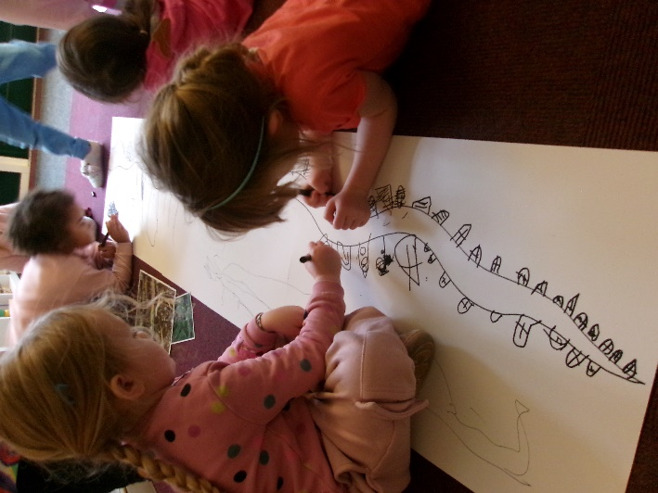
The school is a place of research - Working together to question and improve, our school is a place where children, families and educators work together to improve the quality of learning and teaching experiences, therefore promoting high aspirations, levels of well-being, good dispositions and achievement for all. We believe that a researching school relies on developing a 'listening pedagogy, where all protagonists collaborate and co-operate in reflective dialogue, respecting and encouraging different opinions and ideas, being open to change and innovation.

The school is a place of partnership with children and families - We consider that a genuine, respectful and active partnership between children, their families and the school is central to successful learning. This principle is interrelated and underpins the other school principles and reflects our relational and community ethos. Partnership involves parents, families and staff working together to benefit children in relationships where each recognises, respects and values what the other does and says. Partnership involves responsibility on both sides.

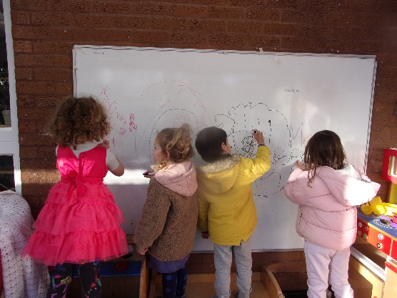
The school is a place where every child is viewed as competent and full of potential - All children have an innate ability to learn from birth. We believe that every child has an incredible capacity to learn and develop through engagement with others and with the world. This principle has inclusion and diversity at its heart and is made visible through the pedagogical approaches of the school, where learning is seen as crossing the borders that separately define disciplines, curriculum and concepts.

Through these we promote the following values for all members of the Nursery community.

❖ Prosocial behaviours of sharing (dividing up or bestowing), helping (acts of kindness, rescuing, removing distress), and cooperation (working together to reach a goal) showing sympathy, showing positive verbal and physical contact, showing concern, taking the perspective of another person, cooperating and social problem-solving that enable children to be in dynamic interactions with other children and adults.

❖ Self-regulation which is the ability to monitor and control our own behaviour, emotions, or thoughts, altering them in accordance with the demands of the situation.

❖ Collaboration that is crucial to successful, independent learning. Through effective collaboration we begin to understand the importance of being reflective, of cooperation, of taking turns, of respecting difference and diversity, of friendship, of being fair, of sensitive listening, active discussion, and of unity.

❖ Resilience and perseverance to be determined to succeed, setting a goal and sticking to it. We aim to foster a willingness to take risks and an acceptance of failure. We take positives from all that we do and learn from our mistakes. We are responsible for our own learning and develop high self-esteem.

❖ Equality incorporates aspects of tolerance, inclusion and diversity. We expect children to have an awareness of the wider world, to celebrate difference and respect the rights of all individuals, both in the school community and beyond.

❖ Compassion is about kindness and concern, about friendship and love, about communicating effectively and understanding the needs of others. Through our focus on this value we expect to develop thoughtful, considerate children who are empathetic, respectful and kind.

❖ Creativity and innovation is the value through which we hope to inspire children to appreciate their uniqueness, to be imaginative and inquisitive. We aim to nurture originality and dynamism in meaning-making.

❖ Critical thinking using purposeful judgment which results in interpretation, analysis, evaluation, and inference and include qualities, concepts, and processes such as creativity, imagination, discovery, reflection, empathy, connecting knowing, subjectivity, ambiguity, and inconclusiveness.

❖ Confidence to explore as active learners and to be adventurous, curious and confident to take risks when experiencing new things.

❖ Ecological awareness and sensitivity by exploring the world to develop curiosity and respect for nature and a love for the outdoors.

❖ Effective communication that enables children to express themselves, listen and respond to the ideas and proposals of others. Independence and self-organisation to be able to work with other children, not always seeking or needing the affirmation or direction of adults.

Further information about the school can be viewed on the school website at http://www.madeleynurseryschool.co.uk


What does it mean to be a Reggio-inspired Nursery School?

Madeley Nursery School has developed its current practice with significant inspiration from the Reggio Emilia pre-schools and infant-toddler centres in Northern Italy. This process has evolved over the past 20+ years following the deepening engagement of the nursery team with colleagues, based elsewhere, nationally and internationally during this period.
There isn’t a single version of what it means to be ‘inspired by Reggio’ and Reggio itself doesn’t stand still. Reggio is a dynamic, evolving context that constantly reflects on its own practice and shares its developing discoveries generously. As a consequence these relationships with Reggio and national connections with others inspired by Reggio, continue to shape the day to day life of the nursery and the nature of the nursery experience for all our children and families. This nursery is a ‘work in progress’ and as the nursery team continually evaluates and interprets its work, incremental changes to the shape or direction of the work enable a greater authenticity to develop.
Madeley Nursery School first became aware of the work of the Reggio Emilia pre-schools in 1997 when The British Association of Early Childhood Education arranged for the touring exhibition of the ‘Hundred Languages of Children’ to be shared at Bethnal Green Museum of Childhood and later that year at Newcastle University. This was the first time that the work of the Reggio Emilia preschools was welcomed to the United Kingdom. Sweden, Australia and the USA had already invited earlier exhibitions as a consequence of interest in the developing pedagogy. In 2005 and 2006 the touring exhibition returned to the UK and was exhibited in Liverpool, Birmingham and Coventry. Additionally week long study tours in Reggio Emilia began to be oﬀered through Sightlines-Initiative based in Newcastle University. Madeley Nursery’s Assistant Head joined the 2006 and 2007 study tours and the school began to develop its interest in Reggio based
practice. Further UK based seminars and conferences began to be oﬀered as well as annual study tours in Reggio Emilia.
Since 2007 the nursery school has been identified, by Ofsted, as an outstanding school and there is no doubt that the Reggio inspired aspects of the school and their outcomes, contributed significantly to these judgements. Developments take time to evaluate and reflect upon and they carry a sense of ‘breathing life into a process’. there’s a need for patience and restraint as well as imagination and courage. Advances and retreats are made on the basis of our research with the children. As a consequence, there is a continuing need for re-consideration of many aspects of the nursery’s processes in order to ensure that there is a good fit between developing pedagogy and practice and the structures that support them.
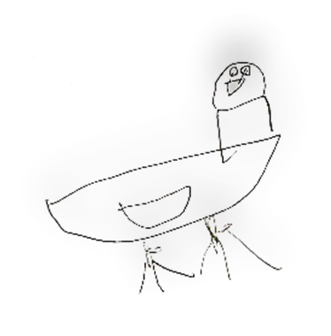
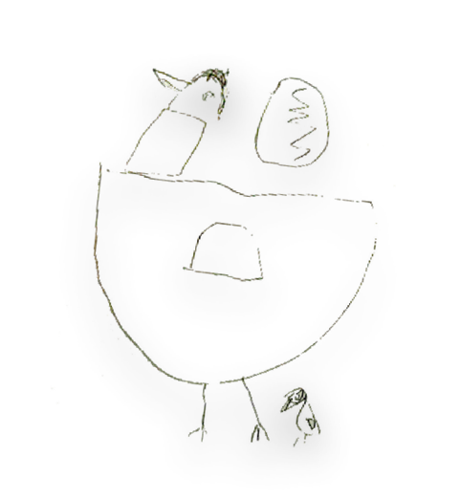
Standing alongside and entangled with inspiration from Reggio Emilia is the schools’ belief in ecology and ecological systems. These ideas not only influence research undertaken by children and staﬀ in the form of annual projects, but also the understanding of leadership and management of the whole school. This view on learning and our ecological focus is influenced by the ideas of English polymath Gregory Bateson, whose work intersected many other fields, including environmentalism, sustainability, and learning. Bateson has influenced the development of the preschools and infant-toddler centres in Reggio Emilia, particularly the work of Loris Malaguzzi and Vea Vecchi. These theoretical proposals describe living and learning at Madeley Nursery School which is resonant with vitality, constantly evolving and full of life.
The Job Description

 | HEADTEACHER JOB DESCRIPTION
Line manager/s: | The Governing Body

Main purpose of the job:
The Headteacher is the leading professional in the school. Accountable to the Governing Body, the Headteacher provides vision, leadership and direction for the school and ensures that it is managed and organised to meet its aims and targets. The Headteacher, working with others, is responsible for evaluating the school’s performance to identify the priorities for continuous improvement and raising standards; ensuring equality of opportunity for all; developing policies and practices; ensuring that resources are efficiently and effectively used to achieve the school’s aims and objectives and for the day-to-day management, organisation and administration of the school.
The Headteacher is a Designated Safeguarding Lead. The designated safeguarding lead takes lead responsibility for safeguarding and child protection (including online safety).
JOB SPECIFICATION

Shaping the Future
Critical to the role of headship is working with the Governing Body and others to create a shared vision and strategic plan which inspires and motivates pupils, staff and all other members of the school community. This vision should express core educational values and moral purpose and be inclusive of stakeholders’ values and beliefs. The strategic planning process is critical to sustaining school improvement and ensuring that the school moves forward for the benefit of its children and wider community.

Professional qualities
Is committed to:
- A collaborative school vision of excellence and equity that sets up high standards for every child, working with the governing body to provide vision, purpose and leadership for the school, and securing effective teaching and successful learning and achievement by children.
- The setting and achieving of ambitious, challenging goals and targets. To ensure continued school improvement, the achievement of objectives and the educational success of the school.
- To review and implement the School Development Plan which, through appropriate consultation, identifies appropriate targets and priorities for ensuring that children achieve high standards and make progress.
- To ensure that the management, finance and administration of the school supports its vision and aims.
- The use of appropriate technologies.
- Inclusion and the ability and right of all to thrive and be the best they can be.

Is able to:
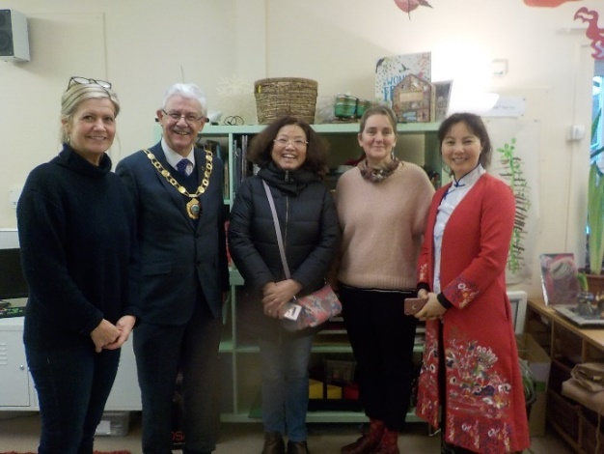
- Think strategically, build and communicate a coherent vision in a range of compelling ways.
- Inspire, challenge, motivate and empower others to carry the vision forward.
- Model the values and vision of the school.
- Monitor, evaluate and review the effectiveness of the school’s practice, policies and priorities.
- Think creatively to anticipate and solve problems.

Leading Learning and Teaching

Professional Duties
A Headteacher has a central responsibility for raising the quality of teaching and learning and for children’s achievement. This implies setting high expectations and monitoring and evaluating the effectiveness of learning. A successful learning culture will enable children to become effective, enthusiastic, independent, collegiate, creative learners, committed to life-long learning.

- To create and maintain an environment which promotes and secures outstanding teaching, vibrant and effective learning, high standards of achievement, good behaviour and discipline.
- To implement, monitor, evaluate and review the curriculum and its assessment to identify areas for improvement and targets for the school and individual children.
- To develop effective links with families and the community to extend the curriculum and improve children’s achievements and personal development.
- To promote respect and understanding of diverse cultures, languages and ethnic groups, including faith groups.
- To teach for a significant proportion of the week.

Developing Self and Working with Others
Effective relationships and communication are important in headship as Headteachers work with and through others. Effective Headteachers manage themselves and their relationships well. Headship is about building a professional learning community which enables others to thrive and achieve. Through the supervision and appraisal process and effective reflective, continuing professional development practice, the Headteacher supports all staff to achieve high standards. To equip themselves with the capacity to deal with the complexity of the role and the range of leadership skills and actions required of them, Headteachers should be committed to their own continuing professional development.

Managing the Organisation
Headteachers need to provide effective organisation and management of the school and seek ways of improving organisational structures and functions based on rigorous self-evaluation. Headteachers should ensure that the school and the people and resources within it are organised and managed to provide an efficient, effective and safe learning environment. These management responsibilities imply constant examination of the roles and responsibilities of those adults working in the school to build capacity across the workforce and ensure resources are deployed to achieve value for money. Headteachers should also seek to build successful organisations through effective collaborations with others.

Professional Duties
Is committed to:
- Distributed leadership and management.
- The equitable management of staff and resources.
- The sustaining of personal motivation and that of all staff.
- The developing and sustaining of a safe, secure and healthy school environment.
- Collaborating with others in order to strengthen the school’s organisational capacity and contribute to the development of capacity in other schools and settings.
- Undertaking the role of Designated Safeguarding Lead.

Is able to:
- Establish and sustain appropriate structures and systems.
- Manage the school efficiently and effectively on a day-to-day basis using ecological principles.
- Delegate management tasks and monitor their implementation.
- Prioritise, plan and organise themselves and others.
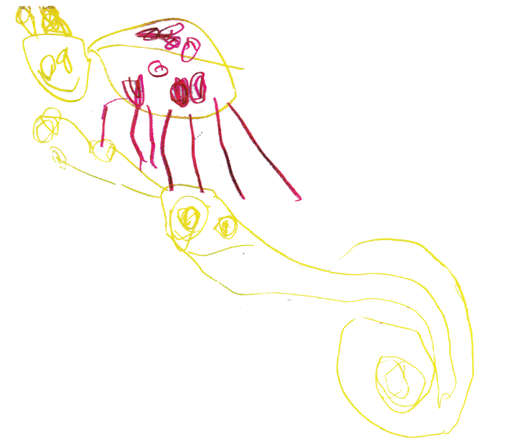
- Make professional, managerial and organisational decisions based on informed judgements.
- Think creatively to anticipate and solve problems.

Securing Accountability
With values at the heart of their leadership, Headteachers have a responsibility to the whole school community. In carrying out this responsibility, Headteachers are accountable to a wide range of groups, particularly children, parents, carers, Governors and the LA. They are accountable for ensuring that children thrive and benefit from high quality education and care, for promoting collective responsibility within the whole school community and for contributing to the education service more widely. Headteachers are legally contractually accountable to the Governing Body for the school, its environment and all its work.

Professional Qualities
Is committed to:
- Principles and practice of school self-evaluation.
- The school working effectively towards the academic, spiritual, moral, social, emotional and cultural development of all its pupils.
- Individual, team and whole school accountability for children’s learning outcomes.

Is able to:

- Demonstrate political insight and anticipate trends.
- Engage the school community in the systematic and rigorous self-evaluation of the work of the school.
- Collect and use a rich and broad set of data to understand the strengths and weaknesses of the school.
- Combine the outcomes of regular school self-review with external evaluations in order to develop the school.

Strengthening Community
Schools exist in a distinctive social context, which has a direct impact on what happens inside the school. School leadership should commit to engaging with the internal and external school community to secure equity and entitlement. Headteachers should collaborate with other schools in order to share expertise and bring positive benefits to their own and other schools. They should work collaboratively at both strategic and operational levels with parents and carers and across multiple agencies for the well- being of all children. Headteachers share responsibility for leadership of the wider educational system and should be aware that school improvement and community development are interdependent.

Professional Qualities
Is committed to:
- Effective teamwork within the school and with external partners.
- Work with other agencies for the well-being of all children and their families.
- Involvement of parents and the community in supporting the learning of children and in defining and realising the school vision.
- Collaboration and networking with other schools to improve outcomes.

Is able to:
- Recognise and take account of the richness and diversity of the school’s communities.
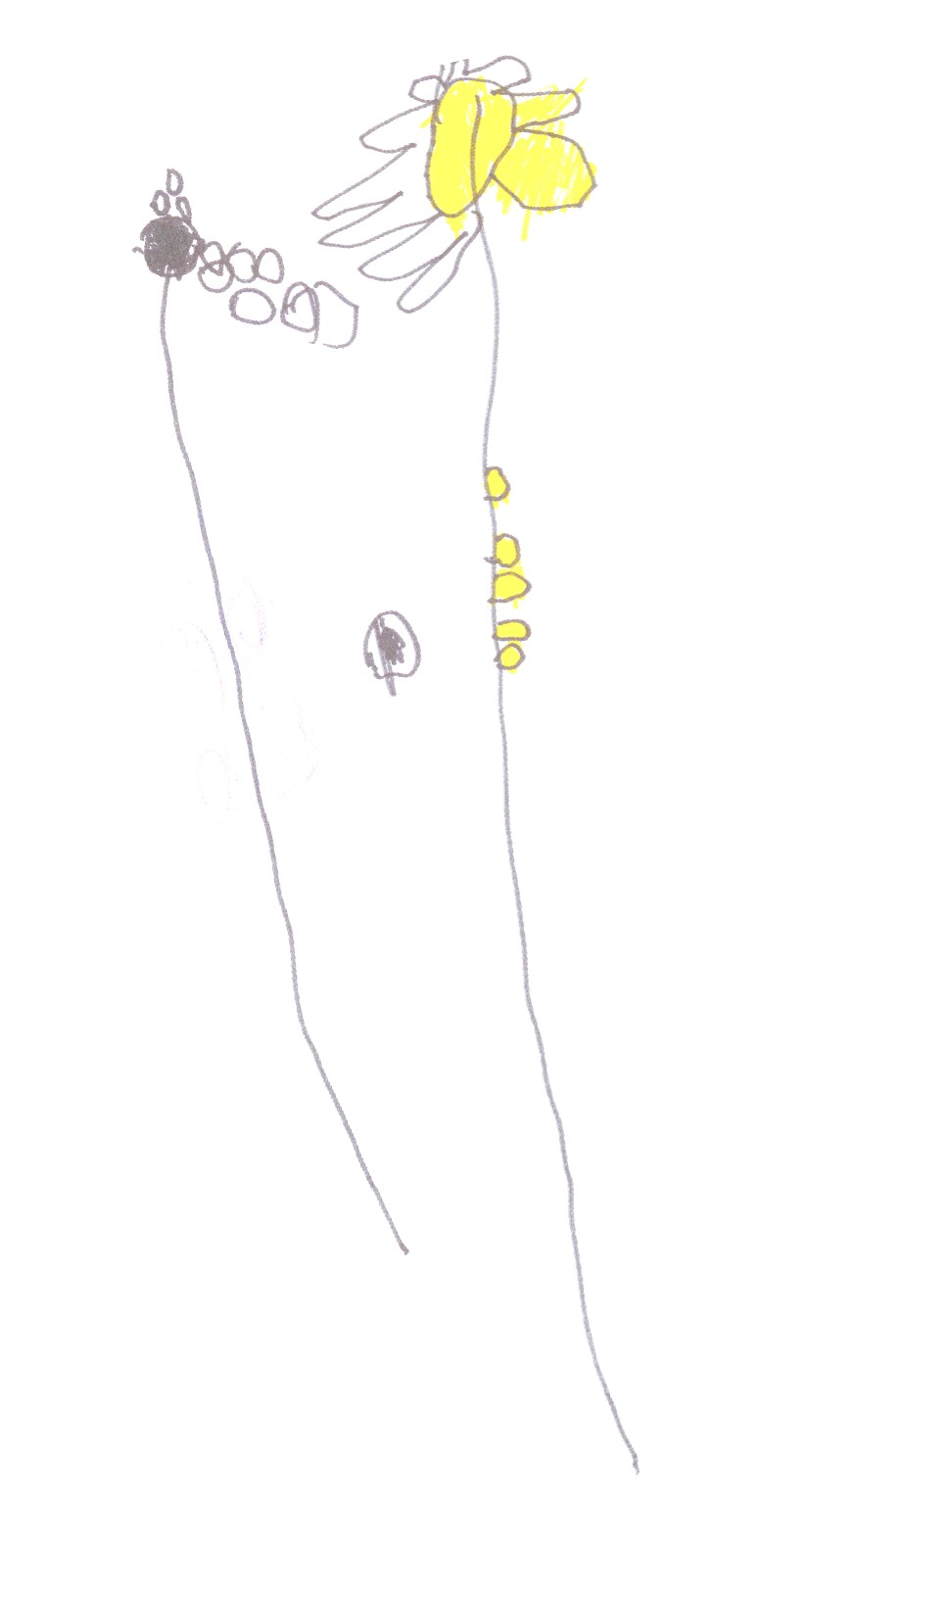
- Engage in dialogue which builds partnerships and community consensus on values, beliefs and shared responsibilities.
- Listen to, reflect and act on community feedback.
- Build and maintain effective relationships with parents, carers, partners and the community that enhance the education and care of all children.
“We always do teamwork at Madeley Nursery, don’t we?” Emlyn

“Yes, every day, and in the winter!” Rory

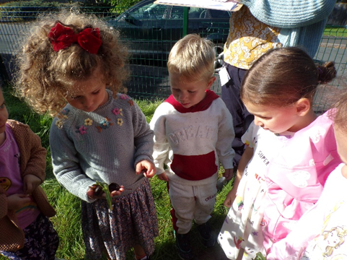

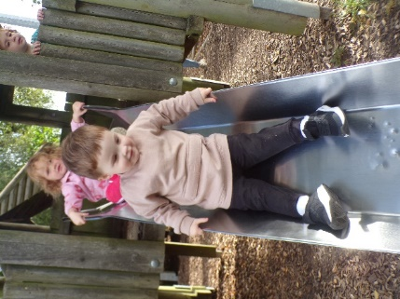


APPOINTMENT OF HEADTEACHER MADELEY NURSERY SCHOOL

PERSON SPECIFICATION / SELECTION CRITERIA

[A] TRAINING AND QUALIFICATIONS

 | Essential or Desirable | Application | Interview | Reference
Qualified teacher status. | E | A
Degree or equivalent. | E | A
Higher degree qualification / Postgraduate courses / Recognised management qualification. | D | A
Completion of NPQH, or similar. | D | A
Evidence of training in preparation for Headship. | D | A | I
Evidence of personal professional development regarding the educational approach inspired by the preschools of Reggio Emilia. | E | A | I
Professional development in ecological theory and education. | D | A | I
Evidence of sustained participation in relevant CPD especially relating to leadership, management and early years pedagogy. | E | A | I | R
Participation in work in other schools and settings. | D | A | I | R
Self-awareness of where additional training is required and willingness to undertake such training. | E |  | I

[B] EXPERIENCE OF TEACHING AND EDUCATIONAL MANAGEMENT

 | Essential or  Desirable | A | I | R
Previous experience of working in a senior leadership role within an education setting, including experience of the following:  school development planning/ monitoring and evaluation/ data analysis and target setting/ policy development and implementation / curriculum development. | E | A | I | R
Extensive experience of teaching within an early years setting. | E | A
Experience of managing, leading and inspiring a team of teaching and support staff, including supporting and developing the team with their own professional development and training. | E | A | I | R
Experience of working in partnership with children, families/ caregivers and the wider community, including other educational settings, to enhance the nursery's offerings. | E | A |  | R
Experience of leading a significant curriculum development to implementation. | D | A |  | R
Firsthand experience of work with governors. | D
Experience of managing educational budgets and finance. | D | A | I | R
Experience of:  appointing and inducting staff; ICT systems for resource and budget management. | D | A |  | R

[C] PROFESSIONAL KNOWLEDGE AND UNDERSTANDING

 | Essential or Desirable | A | I | R
The distinctive nature of a Nursery School. | E | A | I | R
The principles, values and aims of Madeley Nursery School. | E | A
The approaches needed to ensure the positive promotion of diversity, inclusion and equal opportunities and to prepare pupils to live in a diverse society. | E | A | I | R
A passion for incorporating a strong ecological philosophy into the curriculum and every area of nursery life. | E | A | I
How to create, and secure commitment to, a clear vision for an outstanding nursery school through challenging, motivating, inspiring and empowering others. | E | A | I | R
The leadership and management of others within the context of early years including the leadership role of the Head in the development of staff and how to foster an open, fair and equitable culture, managing conflict where necessary. | E | A | I | R
Strategies for leading and managing school improvement. | E | A | I | R
Strategies to promote and sustain individual and team development. | E | A | I | R
The principles and practices of effective school self-evaluation to ensure ongoing invention, discovery and transformation in line with our values. | E | A | I | R
Strategies for developing and strengthening a school’s links with other schools and settings, and the wider community. | E | A | I | R
The leadership role of promoting partnership with parents and carers; understanding and valuing the importance of family involvement in their children’s learning. | E | A | I | R
The implications of a researching / enquiry approach to the curriculum. | E | A | I | R
The ability to implement and oversee a curriculum that aligns with research / enquiry-based learning supporting children’s individual needs and interests while meeting EYFS requirements. | E | A | I | R
Current educational issues, including national policies and legislation. | E | A | I | R
The process of strategic planning. | E | A | I | R
The principles of effective teaching and assessment. | E | A | I | R
Effective learning and teaching strategies. | E | A | I | R
The role of the Governing body. | E | A | I | R
The particular statutory requirements of the Early Years Foundation Stage, including curriculum and welfare, health and safety, Keeping Children Safe in Education and Health and Safety. | E | A | I | R
The procedures and strategies for the effective provision of education and care for children with SEN and disabilities and knowledge of the SEND Code of Practice. | E | A | I | R
Understanding of research / enquiry based learning - (Reggio Emilia Approach) and other regional pedagogies, with the ability to implement and adapt them within the nursery setting. | E | A | I
Awareness of the challenges and changes facing Early Years. | E | A | I | R
An understanding of the way schools can promote personal values and establish a culture of respect. | E |  | I | R

[D] PERSONAL AND PROFESSIONAL QUALITIES AND ATTRIBUTES

 | Essential or Desirable | I | R
A genuine enthusiasm and respect for work with young children and a commitment to their development, dignity and wellbeing. A champion for children’s voices and their individual needs. | E | I | R
Ability to lead and provide a clear vision. Ability to be both clear and incisive and responsive and intuitive in your thinking. Ability to motivate and inspire the nursery community. Ability to delegate responsibility, set high standards, provide a focus for improvement and foster a culture of excellence, creativity, and inclusion. | E |  | R
Experience in Reggio theory and practice and passionate about this approach of educating. | E | I
Sensitive to the ways that ecology informs every aspect of life at Nursery. | E | I | R
Ability to both implement and manage change, monitor and evaluate its impact, and reflect and respond accordingly. | E |  | R
The desire and motivation to continue ongoing investigation into learning and deep pedagogical research. | E | I
Deep compassion for the children, setting, staff, families, community, and safe learning spaces. | E |  | R
Embodiment of the ideas, beliefs and ethos of the Reggio/ecological ‘Madeley Nursery’ way of learning. | E | I | R
Excellent communication skills with a range of audiences with the ability to engage effectively and work in partnership with children, families, staff, and external agencies. Flexible and approachable. Resilient under pressure. Able to deal sensitively with people and resolve conflicts. | E | I | R
Inspire, challenge, motivate and empower others to carry forward the shared vision. | E | I | R
The ability to maintain a supportive, positive, energetic and cheerful atmosphere, even in challenging situations, helping to create a joyful environment in which both children and staff can thrive and achieve their potential. | E |  | R
Demonstrate personal enthusiasm for and commitment to the educational approach of the school. | E | I | R
Develop effective teamwork; commitment to the development of all practitioners within nursery, continuing the journey they have already begun. | E | I | R
Promote and maintain effective relationships. | E | I | R
Prioritise, plan and organise self and others; manage the balance of teaching, management and leadership elements of your role. | E | I | R
Think creatively in order to anticipate and solve problems. | E | I | R
Listen to and reflect on feedback. | E | I | R
Demonstrate an ability to communicate to a range of audiences and in a range of media. | E | I | R
A commitment to personal research young children’s learning. | E | I | R
An innovative approach to curriculum development and problem solving, with a willingness to experiment with new ideas. | E | I | R
Ability to develop and implement a School Development Plan. | E |  | R
Capable of ambitious vision for the future. | E | I
Resilience and strength of character; a proud and committed champion for Madeley Nursery. | E | I

[E] APPLICATION FORM AND LETTER

The application form should be fully completed and legible.
The letter should be clear, concise and address the criteria identified in the person specification. Please include your response to the quotation on page 8 of this pack.

A = Application
I = Interview
R = Reference

