Old Park Primary School and Nursery
Candidate information pack
Post title: Class Teacher

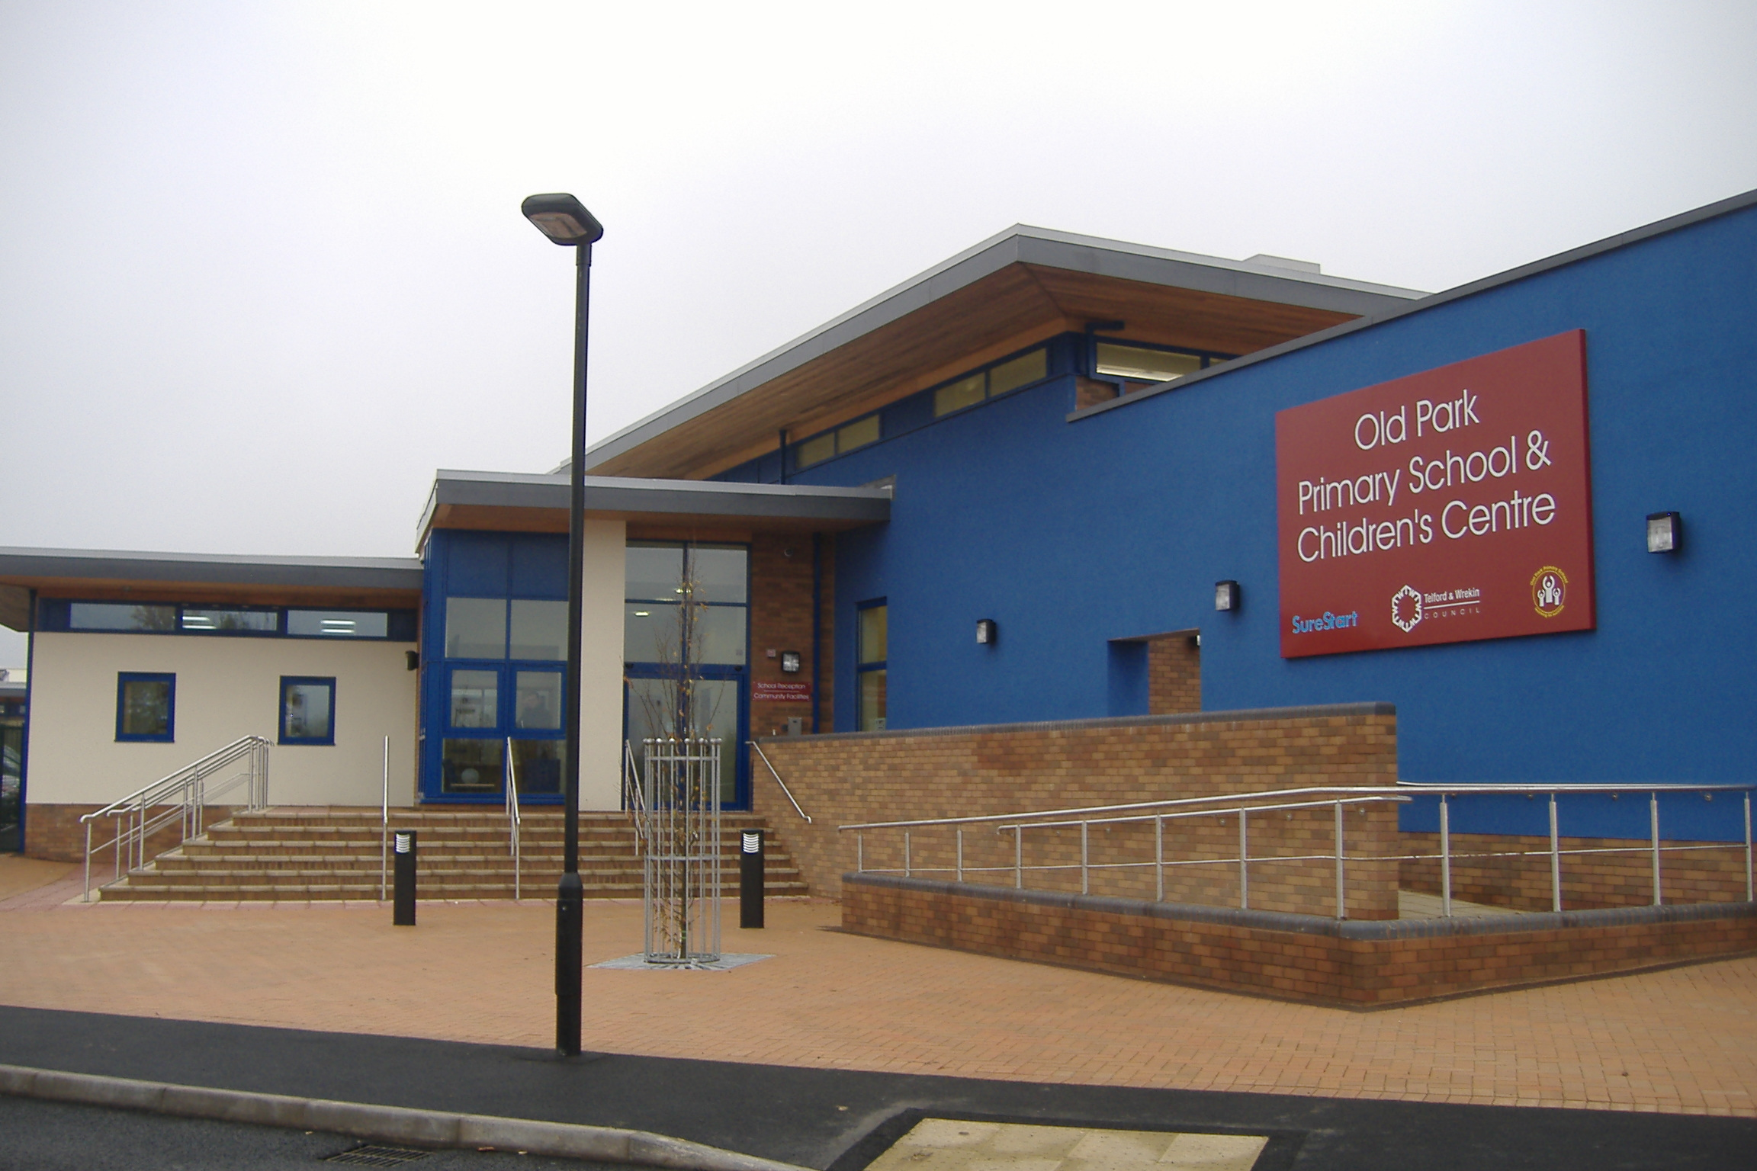

Old Park Primary and Nursery School
Brunel Road
Malinslee
Telford
TF3 2BF

Telephone: 01952 387250

E-mail: oldparkprimary@telford.gov.uk
Website: www.oldparkprimary.co.uk

X: @OldParkPrimary

Headteacher: Mr J Foster

Headteachers welcome:
As headteacher I am extremely passionate about education and ensuring that all students achieve their best. I believe education is about more than simply learning, it is about creating well-rounded individuals who develop a thirst for knowledge that will grow into life-long learning.
Our vision of ‘reaching for success’, is one that I want everyone in the school community to fully embrace, and we promote our core values of belonging, respect and responsibility in everything that we across the school.
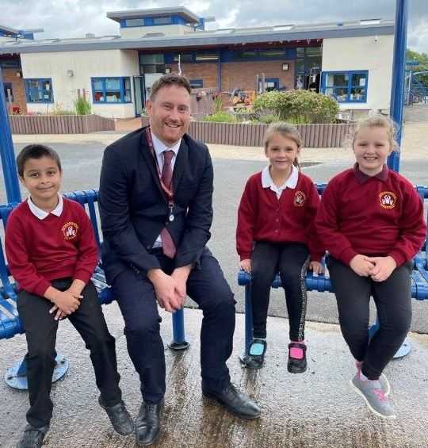
At Old Park we believe in creating a nurturing environment where children can thrive through promoting values such as kindness, respect and tolerance.
We are all committed to putting the children’s wellbeing first and striving to make sure all their needs are met. We were delighted that Ofsted recognised this in March 2023, highlighting that “creativity and community are the heart of Old Park. It is a happy and friendly school, where everyone is welcome and valued as individuals.” We see every student as an individual and want to help them discover and nurture their talents and interests.
We want to deliver a broad, balanced, and rich curriculum which is enhanced by a range of great projects, external visitors, and extra-curricular activities. Through our curriculum we expect all students to make a positive contribution to the school, the local community and wider society.
We are so proud of our staff who go the extra mile to inspire children, creating lifelong memories through offering creative and exciting opportunities where children can work together, support and learn together.
Music is central to life at Old Park, and our In Harmony programme provides specialist music lessons for all children. Children from year 2 to year 6 will learn an instrument and play in one of our 5 orchestras. This programme is fully funded, all lessons and instruments are provided free of charge.
We are really happy that the hard work of the school community is recognised in a range of ways including being TES Outstanding Primary School of the Year in 2011; Pearson National Teaching Awards Bronze winner in the category; Making a Difference – Primary School of the Year 2021 and 2022, The Music Partnership Platinum Award, Anti-Bullying Alliance Gold Award and School Games Gold Award.
We extend a warm invitation to anyone who would like to learn more about our school. Please contact the office if you would like to visit or talk to a member of the team.
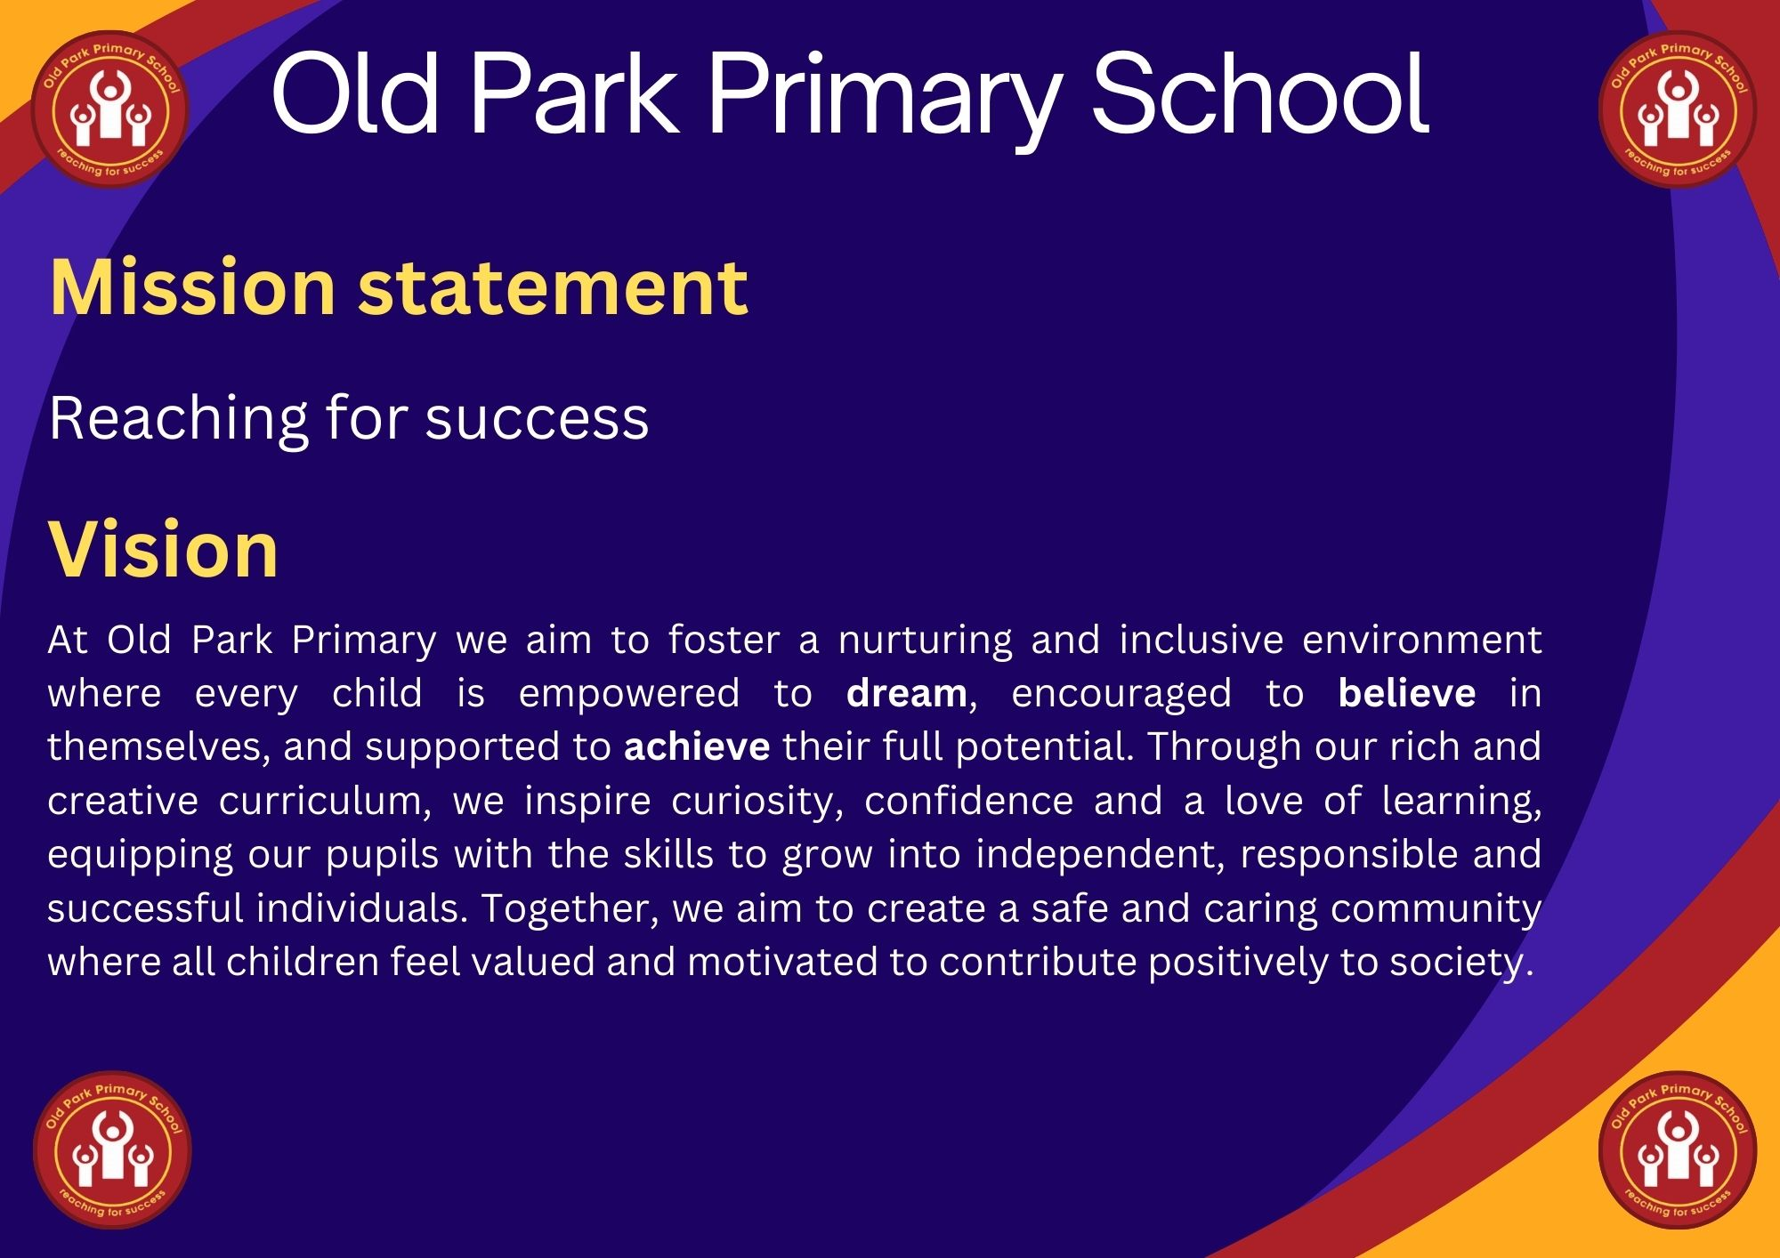

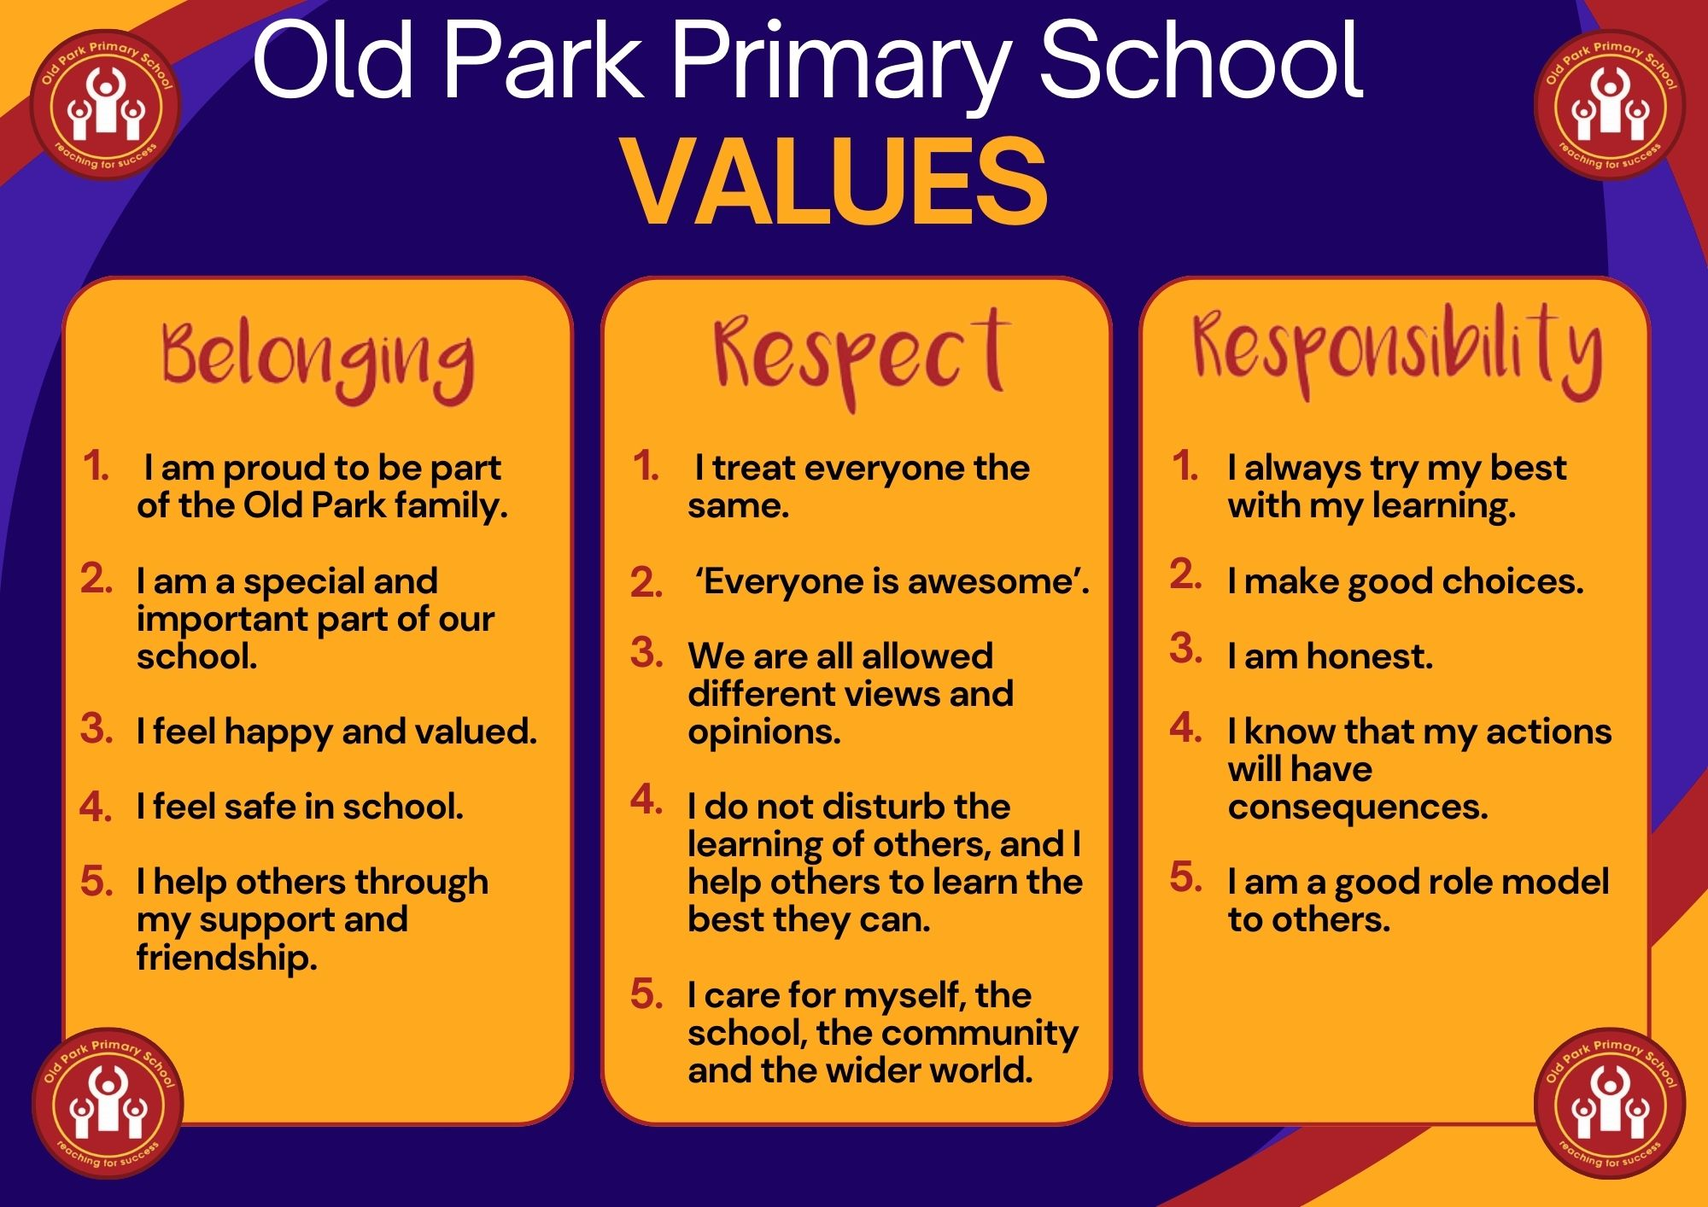

Old Park Primary School and Nursery: Job description

Post title: | Class teacher
Purpose: | - Fulfilling the professional responsibilities of a teacher, as set out in the Schools Teachers’ Pay and conditions document.  - Meeting the expectations set out in the Teachers’ Standards.
Reporting to: | Phase leader / Senior Leadership Team
Salary/Grade: | MPS/UPS
Disclosure level | Enhanced
Duties and responsibilities

Teaching | - Plan and teach lessons to the classes they are assigned to teach within the context of the school’s plans, curriculum and schemes of work.  - Teaching according to the educational needs of the pupils assigned to them, including the setting and marking of their work.  - Assessing, recording and reporting on the development, progress and attainment of assigned pupils.  - Set challenging but realistic targets for all children in the core subjects. These targets are to be monitored closely and reviewed, with the aim of raising standards and achievement.  - To teach children of any age within the foundation, key stage one or key stage two at the discretion of the headteacher.  - Provide appropriate guidance and planning for teaching assistants in order for them to undertake their duties.
Whole school organisation, strategy and development | - Contribute to the development, implementation and evaluation of the school’s policies, practices and procedures in such a way to support the schools’ values, vision and ethos.
Management of staff and resources | - Direct and supervise support staff assigned to them, and where appropriate other teachers.  - Contribute to the recruitment, selection and professional development of other teachers and support staff.  - Deploy resources delegated to them.
Health, safety and behaviour for learning. | - Follow the school behaviour policy to maintain good order and discipline among the pupils and safeguard their health and safety both when they are authorised to be on the school premises and when they are engaged in authorised school activities elsewhere.  - Promote the safety, well-being and safeguarding of all pupils.
Professional development | - Actively participate in school CPD sessions.  - Carry out action research within school as directed by the SLT.  - Participate in arrangements for the appraisal and review of their own performance and, where appropriate of other teachers and support staff.  - Participate in arrangements for their own further training and professional development and, where appropriate that of teachers and support staff including induction.
Communication | - Communicate with pupils, parents and carers.  - Communicate and work with colleagues and other relevant professionals.  - Collaborate and work with colleagues and other relevant professionals within and beyond the school.
Cover | - Subject to national guidelines, cover rarely with exception of those staff who are under allocation in their timetable, where cover will be detailed on the timetable.
Statutory assessments (external examinations) | - Participating in arrangements for preparing pupils for statutory assessments and in assessing pupils for the purpose of such examinations; recording and reporting such assessments; and participating in arrangements for pupil’s presentation for such assessments.
Early Career Teacher (ECTs) | - To participate in induction as required.
This job description is current at the date shown, but following consultation, may be changed by management to reflect or anticipate changes in the job which are commensurate with the salary and job title.

We will endeavour to make any necessary reasonable adjustments to the job and the working environment to enable access to employment opportunities for disabled job applicants or continued employment for any employee who develops a disabling condition.

Old Park Primary School and Nursery: Person specification

Post title: Class teacher | Essential | Desirable
Qualifications and training
A good degree, or equivalent
GCSE passes in English, Mathematics and one Science subject
Qualified teacher status or training to become a teacher (Early Career Teacher roles only)
Evidence of continued professional development
Training in teaching phonics
Experience
Experience of teaching across more than one key stage
Experience in teaching a foundation subject
Highly competent in using technology within the classroom
Professional knowledge and understanding
Have a knowledge and understanding of a range of teaching and learning, behaviour management strategies and know how to use and adapt them.
Know and understand how to personalise learning and provide opportunities for all learners to achieve their potential.
Know the assessment requirements for the key stage/subject they are trained to teach.
Have a secure knowledge and understanding of their subjects/curriculum areas and related pedagogy to enable effective teaching across the age and ability range.
Know how to use statistical information to evaluate the effectiveness of their teaching and to monitor progress and raise attainment.
Knowledge of the legal requirements, policies and guidance on the safeguarding and promotion of the well-being of children.
Demonstrate awareness and understanding of the implication of equality and diversity in education.
Understand how pupils with additional learning needs and SEND may be integrated in the classroom.
Professional skills
Able to plan for progression across the age and ability range, designing effective learning sequences, demonstrating subject/curriculum knowledge.
Able to use a range of teaching and learning strategies and resources.

Ability to make effective use of a range of assessment, monitoring and recording strategies to assess leaning needs and set challenging learning objectives and raise standards.
Able to provide timely, accurate and constructive feedback on attainment, progress and areas for development.
Demonstrate the ability to work independently and collaboratively as a member of a team, sharing and developing effective practice.
Have high expectations of pupils including a commitment to ensuring they can achieve their full potential and to establishing fair, respectful, trusting, supportive and constructive relationships with them.
Be aware of the policies of the school and share in the collective responsibility for their implementation.
Able to communicate effectively, both orally, in writing and electronically with pupils, colleagues, parents/carers and professionals/stakeholders.
Demonstrate positive values, attitudes and behaviour and adopt high standards of behaviour in their professional role.
Demonstrate the ability to act upon advice and feedback and be open to coaching and mentoring.
Demonstrate reliability and integrity.
Have good organisation skills.

