



**Applicant Information Pack**

Food Technology Technician

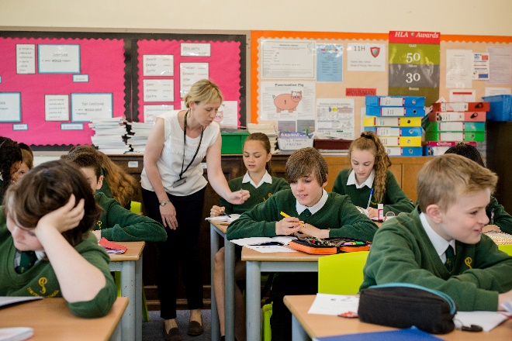



*Selfless – Self Assured – Successful*

 

**Headteacher Letter to Applicants**

The Priory School is an oversubscribed, 11-16, comprehensive situated in a popular, residential area of the County Town of Shrewsbury. There are approximately 840 students on roll with a six-form entry. The school has an excellent reputation across the county.

Our main school building dates from the late 1930s, with a mix of additional classroom blocks added over time, to cater for the growing needs of the school. Our latest ‘Maths Block’ opened in 2019 and symbolises our determination to provide our students with a first-class environment, conducive to learning.

As soon as you enter our school you gain a ‘feel’ for our very special ethos and culture. Students conduct themselves in an exemplary manner and have high expectations of their own and others’ conduct, both in and out of lessons. They are a pleasure to teach and be with. We are an inclusive school and value the diversity of our student body. Outcomes for our students are above average and progress over the last three years has improved year on year. We are determined to ensure this remains the case and constantly reflect on all that we do to ensure we continually improve.

We have a vibrant House System that embodies all we stand for and our students participate in a range of activities, in large numbers. The system helps us to celebrate a range of talents and interests, complementing an extensive extra-curricular programme and has become an integral part of ‘Priory Life’. We believe education is about developing the individual holistically, not just academically. As a result, we have a rich and broad curriculum, to ensure the development of all our students into Selfless, Self-Assured, and Successful individuals.

Our staff are a close-knit team who are dedicated to ensuring our students have the best experience of school life. School leadership are committed to their continued professional development and have placed significant emphasis on staff well-being; reviewing workload to support a healthy work-life balance.

The successful applicant will be joining us at an exciting time of our development, both as a school and as part of an evolving multi-academy trust. They will work within a school, which prides itself on being outward facing, dynamic and aspirational whilst retaining an important feel of the traditional.

If you choose to join The Priory School you will not only benefit from joining an exceptional school, you will greatly benefit from working within an aspirational family of schools. Please take time to view our website <https://priory.tpstrust.co.uk/> for more details.

Alison Pope, Headteacher

**About our Trust**



The 3-18 Education Trust is currently made up of six schools and derives its name from the age range of the pupils and students who attend those schools. We have an inclusive ethos, defined by age and we recognise that education is a continuous process, secured through consistent values and a strong transition (through the key stages).

**Our Vision:**

To ensure every individual is in a great school.

**Our Mission:**

To celebrate the diverse nature, culture and identity of our individual schools, whilst enjoying the benefit of the team, so that each school is reciprocal in their support for one another and achieves together.

**Our Values:**

* Accomplished: to provide high quality education and training for all
* Resilient: to be solution focused and able to intelligently manage challenges
* Compassionate: to show care and understanding towards others

Not only do we pursue the important dimension of achieving the best results for each student regardless of their starting point, but we also believe strongly that education is about developing well-rounded individuals who are ready, willing and able to make their contribution to society.

Please take a look at our Trust website <https://www.3-18education.co.uk/> for more details. For further information about our schools, please click on the links to their websites below:

 <https://www.3-18education.co.uk/schools/bowbrook-primary/>

<https://www.3-18education.co.uk/schools/coleham-school/>

 <https://www.3-18education.co.uk/schools/the-priory-school/>

 <https://www.3-18education.co.uk/schools/st-martins-school/>

 <https://www.3-18education.co.uk/schools/thomas-adams-school/>

 [https://www.3-18education.co.uk/schools/william-brookes-school/](https://www.3-18education.co.uk/schools/thomas-adams-school/)

**Job Description**

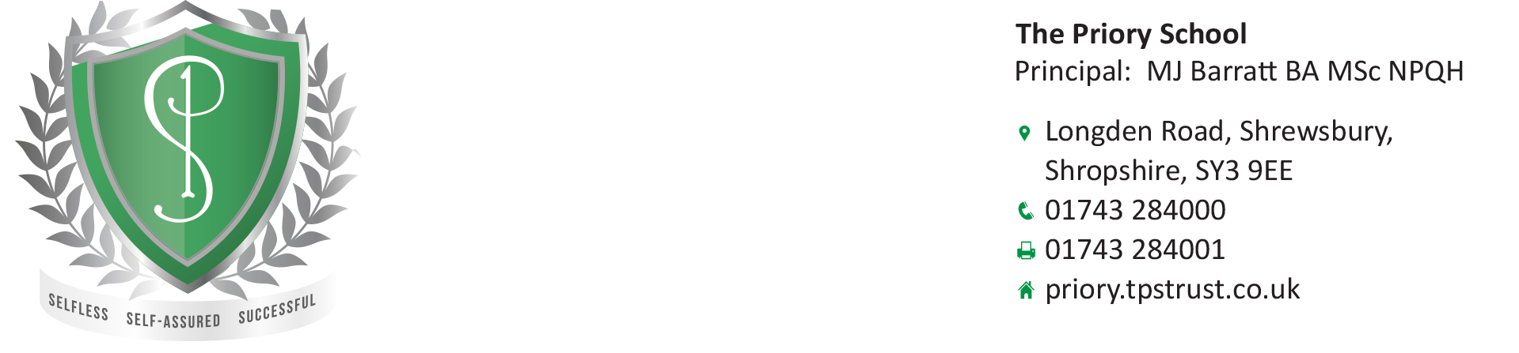



|  |  |
| --- | --- |
| **Title of Post** | Food Technology Technician |
| **Post Status** | Permanent |
| **Grade and SCP** | 5 SCP 5-6 |
| **Reporting to** | Head of Technology |

**Main Purpose**

* To provide specialist technical and administrative support predominantly working within the Food Technology Department.

**Duties & Responsibilities**

* General maintenance of technology rooms and equipment
* Preparing materials for practical lessons – weighing and measuring ingredients for group work, demonstrations and students who receive funding for ingredients.
* Ensuring that equipment is ready for lessons – setting up demonstrations
* Filing and photocopying resources
* Making regular safety checks on equipment – electrical items and ensuring food storage areas are organised and clean.
* Placing orders and checking deliveries
* Checking, cleaning and sanitising equipment before and after use by a class for quantity and damage
* Maintain laundry flow and follow health and safety regulations
* Supporting pupils in Technology lessons
* Follow health and safety checklist before and after practical lessons
* Supporting Technology teachers during lessons, educational visits and activities in school
* Complying with appropriate Health and Safety regulation
* Using a computer to produce labels and lists
* Using specialist equipment

**Professional development**

* Help keep knowledge and understanding relevant and up-to-date by reflecting on your own practice, liaising with school leaders, and identifying relevant professional development to improve personal effectiveness
* Take opportunities to build the appropriate skills, qualifications, and/or experience needed for the role, with support from the school

**Other Responsibilities**

* Comply with and assist with the development of policies and procedures relating to child protection, health, safety and security, confidentiality and data protection, reporting all concerns to an appropriate person.
* Be aware of and comply with all school policies and procedures
* Be aware of and support difference and ensure equal opportunities for all
* Contribute to the overall ethos and aims of the School and Trust
* Appreciate and support the role of other professionals
* Attend and participate in relevant meetings, training and learning activities as required

The postholder may be required to carry out any other duties that are commensurate with the post. Whilst every effort is made to explain the main duties and responsibilities of the post each individual task undertaken may not be identified.

This job description is subject to review, in negotiation with the post holder at any time. However, an annual review of this job description and allocation of responsibilities will take place as part of agreed performance management arrangements.

**Person Specification**

|  |  |  |
| --- | --- | --- |
| **Criteria** | **Essential** | **Desirable** |
| **Qualifications** | * GCSEs at grades 9 to 4 (A* to C) including English and maths * Ability to plan and organise effectively | * Certificate / Qualification in food handling and preparation. |
| **Work or relevant experience** | * Work experience working in a relevant setting |  |
| **Skills and Abilities (relevant to the post)** | * Sufficiently fluent in spoken English to ensure effective performance in the role * Good organisational skills * Excellent verbal communication skills * Evidence of working well as part of a team * The ability to remain calm in stressful situations | * Skills and expertise in understanding the needs of all pupils |
| **Knowledge and understanding** |  | * Knowledge of guidance and requirements around safeguarding children |
| **Personal Qualities** | * Enthusiastic and passionate about Food * Sets high standards for themselves including safety * Is able to work collaboratively as part of a team * Is able to work under pressure * Ability to bring to the role, initiative, enthusiasm and commitment * Flexibility and reliability * Willingness to develop skills with further training |  |
| **Special Conditions** | * Willingness to undertake an enhanced Disclosure and Barring Service (DBS) check. |  |

**Additional Information about The Priory School**

Set up as a girls’ grammar school in 1939, The Priory School became a mixed comprehensive when Priory Boys’ Grammar School (now Shrewsbury Sixth Form College) joined in 1980.

The Priory School has a reputation for academic excellence and it is our aim to ensure that every child is encouraged to pursue their own personal excellence and provide an education that will encourage students to become lifelong learners.  It is also our belief that this can only be achieved if parents, staff and governors work together to ensure the best possible support and provision for each child.

The Priory School encourages students to take on responsibility. In Year 10, students are able to apply for the positions of School Captains. The duties of School Captains and Deputies are various and include them acting as ambassadors for the school, setting an annual theme which is then pursued throughout the whole school. There is also The School Council, which is used to act as an executive body receiving reports from and consulting with different student groups with specific responsibilities within the school.

The school operates a house system comprising of six houses Attenborough, Frank, King, Hawking, Nightingale and Parks.  One form in each year group belongs to one of the houses, which are run entirely by Year 11 students.  The activities that they run vary from inter house sports through to fund raising.  In March the House Cup is awarded to the winning house.

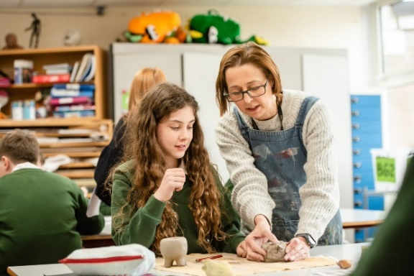The Priory School is the lead school for Shropshire and Telford Education Partnership the DfE sponsored Teaching School Hub which covers Shropshire and Telford and Wrekin. We work in collaboration with three other former teaching school alliances to deliver the Early Career Framework, act as an Appropriate Body for Early Career Teachers, deliver the full suite of NPQs, offer School Direct PGCEs through our wider partnership as well as provide accredited CPD to meet the needs of the area. This signals a very exciting new chapter for the school in its contribution to the wider development of teaching and support staff across the local area.

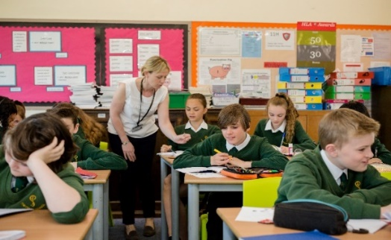

**What We Offer**

The willingness to support completion of an **accredited CIPD professional qualification** (current value of qualification is £7,000, which we would fund in full, subject to conditions).

**In addition to a comprehensive induction and a commitment to your ongoing training and career progression, we also offer:**

* A competitive salary
* Access to the Trust’s Employee Assistance Programme, which includes 24 hour access for you and your family members to legal, financial, health, parenting and life advice
* 1:1 Counselling Service
* Discount Scheme for high street retailers, mobile phone providers, holidays, electrical goods, supermarkets, restaurants, cinema, etc.
* Cycle to Work Scheme
* Childcare Voucher Scheme or Tax-Free Childcare Scheme
* Access to freshly made hot meals or deli-style food on site
* Teachers Pensions (23.68% employer contributions)
* Local Government Pension Scheme (17.9% employer contribution)
* Generous Sickness Payment Scheme
* Eye Testing Scheme
* Flexible Working Policy
* Special Leave Policy
* Member of the Valued Worker Scheme (accredited by our recognised unions)
* A Disability Confident Committed Employer
* Continuous Professional Development (CPD)
* Collaborative working culture and professional development opportunities across our Trust schools

We are also currently exploring:

* Electric/Hybrid Car Lease Scheme
* Healthcare Scheme

**A**

**A**

**The Appointment Process**

An application form is available to download from the school website: <https://priory.tpstrust.co.uk/contact-us/current-vacancies/>

Please send completed applications to: [pri-hr@pri.318education.co.uk](mailto:pri-hr@pri.318education.co.uk)

Interviews will be offered to those applicants who best demonstrate how skills, abilities and experience match the person specification, taking into consideration the job description.

**Closing date for applications: 10am Monday 7th October 2024**

**Interviews will take place on Friday 11th October 2024**

**Please note:**

* It is essential that all elements of the application form are completed in full.
* We do not accept CV’s in support of an application.
* Appointments will be subject to clearance in respect of medical fitness, satisfactory references, right to work in the UK and criminal disclosure.
* This post is exempt from the Rehabilitation of Offenders act 1974 and as such the applicant who is appointed to this post will be subject to an Enhanced Disclosure before the appointment is confirmed. This check will include details of cautions, reprimands or warnings, as well as convictions and non-conviction information. Once appointed, the successful applicant may also be required to apply for an Enhanced Disclosure at intervals during the course of their employment whilst in this post.

If invited for interview, **you are required to bring evidence of your qualifications and appropriate documents to initiate the DBS application process** should you be the successful candidate.

*The 3-18 Education Trust is committed to safeguarding and promoting the welfare of children and young people, as such this post requires acknowledgement and understanding of safeguarding and child protection policies. Policies can be found on the school website* [*https://priory.tpstrust.co.uk/*](https://priory.tpstrust.co.uk/)