Sir Alexander Fleming Primary School and Nursery

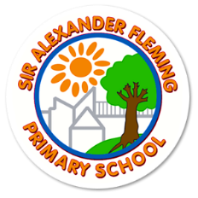

Application Information Pack

2025-2026

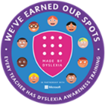  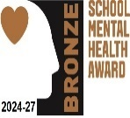  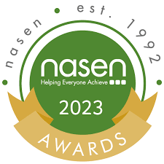



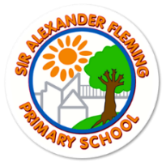Headteacher Welcome

I would like to thank you for taking the time to read this information about Sir Alexander Fleming Primary School and Nursery, and for considering our school as potential place for your future employment. Looking for a new job can be an exciting but daunting time, so I hope the information provided in this booklet helps you in deciding whether to apply for the position you have seen advertised.

As a values-based school, we strongly urge you to read the information about our school values, vision and aims, to ensure that they align with your own values and beliefs. We also hope that from reading this booklet, you will gain a sense of what the school is like. This booklet will give you a glimpse into life at SAF, but I would strongly encourage you to visit the school to experience the tangible ethos and atmosphere of the school.

You can also visit our school website to find out more information by clicking on the following link: [Sir Alexander Fleming Primary School – News and Information for Parents and Carers](https://siralexanderflemingprimaryschool.org.uk/) .

I am proud to be the headteacher of such a vibrant, diverse, nurturing and inclusive school. I have worked at this school for nearly 18 years and have been the headteacher for five years. Without a doubt, the best part of working at Sir Alexander Fleming, is the wonderful, hard-working and friendly children you will meet and the incredibly supportive staff you will work alongside. Working at SAF is a joy and a privilege!

Best wishes

Katy Tomlinson

Headteacher

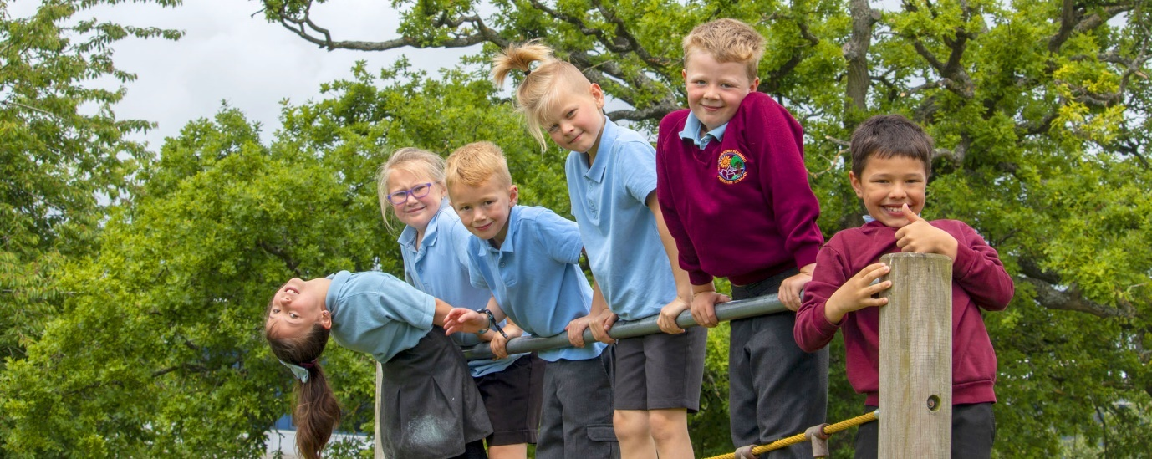

Values, Vision and Aims

Safe Respect Pride Brave Success

‘Belonging, Being, Becoming’

**Sir Alexander Fleming is a learning community from the Early Years to the end of Key Stage Two where…**

We believe that we make a difference by creating a secure, stimulating, supportive environment where emotional health and well-being are prioritised, and children are given the confidence to face setbacks with hope and resilience. Our children develop independent learning skills, courage and self-confidence; they reflect on their ideas, use their initiative and believe that they can and will **succeed.**

This allows children to build their knowledge and understanding through learning that captures their interests, stimulates their imagination and allows them to be **proud** of themselves. Our children know more and remember more because their learning journey is exciting and engaging from the very beginning. A love of reading is at the heart of every child’s learning journey from the Early Years until Year 6 and beyond.

We believe that children should develop **respect** for themselves, value the contributions of others and acquire the skills to be **safe** and **succeed**, in our ever-changing society. We understand children’s wellbeing is at the centre of everything that we do and is fundamental to achieving success. Our pupils feel **safe**, happy and supported in their learning and we ensure that they acquire the skills to staying **safe**when online both in school and at home.

Dreams and aspirations are harnessed and nurtured with exciting and engaging school trips and visitors leading to life-long memories. Every child is given the opportunity to develop their interests and skills in a wide variety of the arts including music and drama. Outdoor learning opportunities are enjoyed by every child; this contributes to their knowledge and understanding of subjects.

Children that attend Sir Alexander Fleming extend their experience, knowledge, imagination and understanding so that they are **brave** enough to realise their potential for learning and their capacity for enjoyment.

**Our School Motto**

When choosing our new school motto, we wanted to ensure that our children were at the heart of it and that it had meaning.



**Belonging**: knowing where and with whom you belong is integral to human existence. Children belong first to a family, a cultural group, a neighbourhood and a wider community. Belonging acknowledges interdependence with others and the basis of relationships. Throughout life, relationships are crucial to a sense of belonging. Belonging is central to being and becoming in that it shapes who children are and who they can become.

**Being**: childhood is a time to be, to seek and make meaning of the world. **Being** recognises the significance of the here and now in children’s lives. It is about the present and them knowing themselves, building and maintaining relationships with others, engaging with life’s joys and complexities, and meeting challenges in everyday life.

**Becoming**: children’s identities, knowledge, understandings, capacities, skills and relationships change during childhood. They are shaped by many different events and circumstances. **Becoming**reflects this process of rapid and significant change that occurs in the early years as young children learn and grow. It emphasises learning to participate fully and actively in society.

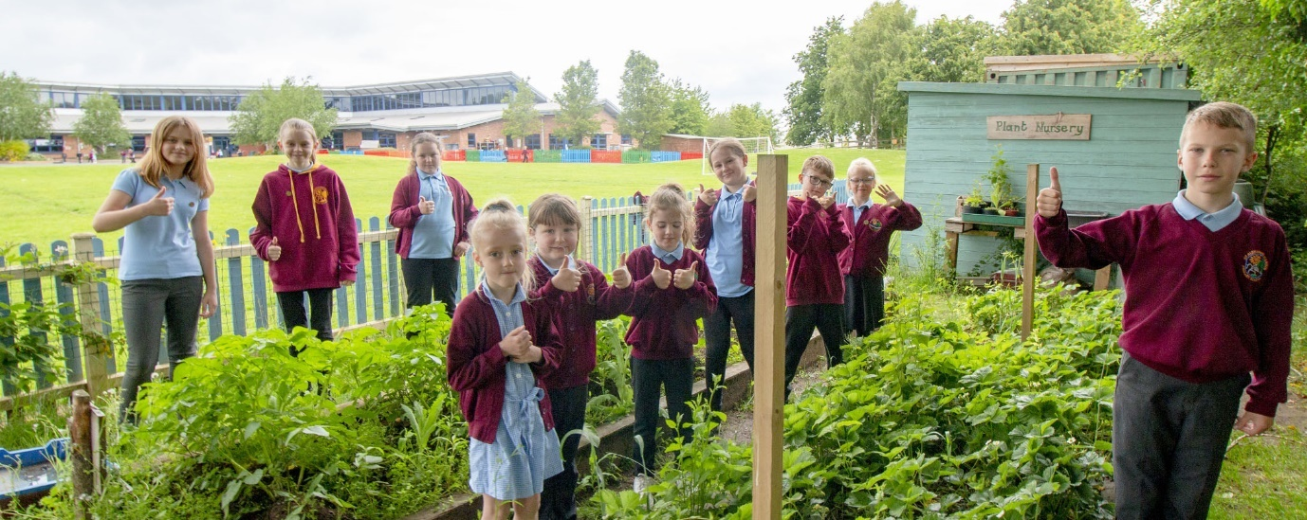

Our School Context

Sir Alexander Fleming Primary School and Nursery is situated in Sutton Hill, Telford. The school originally consisted of separate junior and infant schools which opened in the late 1970s. In 2002, the schools amalgamated to form Sir Alexander Fleming Primary School and Nursery. The school occupies an enviable green site which gives superb opportunities for outdoor education in our Hazels Garden or Eco-Garden. In 2023, we won RHS Primary Garden of the Year and were presented with awards by famous gardener, Frances Tophill.

There are currently fourteen classes from Reception to Y6 and an attached nursery, with over 370 children on roll in total. We have 2 specialist Nurture provisions that focus on developing the SEMH needs of our children and a TLC area. We also have The Hive which is our SEND provision that is led by an experienced teacher and The Nest which focuses on developing Speech and Language. In September 2023, our school won the NASEN Primary SEN Provision of the Year award.

One of the greatest strengths at Sir Alexander Fleming Primary School and Nursery is that it serves a very diverse community. We place great value on the backgrounds and heritage of all pupils. As a result, we have built a diverse and supportive learning community with pupils at the heart of everything we do, underpinned by a strong inclusive ethos.

At the last full Ofsted inspection in November 2024, the school was graded ‘Good’ overall and ‘Outstanding’ for Behaviour and Attitudes. The opening bullet points of the report states,

“Sir Alexander Fleming Primary School is a warm and welcoming school. The school’s motto of ‘Belong, Being, Becoming’ shines through. Staff want the best for pupils and pupils want to do their best to please staff. Pupils show they enjoy learning through their excellent attitudes in lessons. Their behaviour in and out of lessons is exemplary.”

“The school quickly identifies any SEND that pupils may have. Following this early identification, the school puts appropriate and personalised help in place. Pupils with SEND achieve well from their individual starting points.”

The full report is available to view here: [50264033](https://files.ofsted.gov.uk/v1/file/50264033)

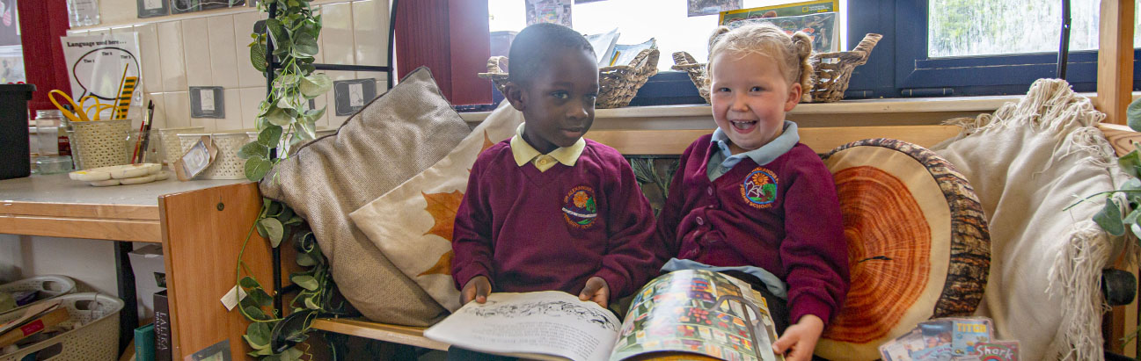

What pupils say about our school…

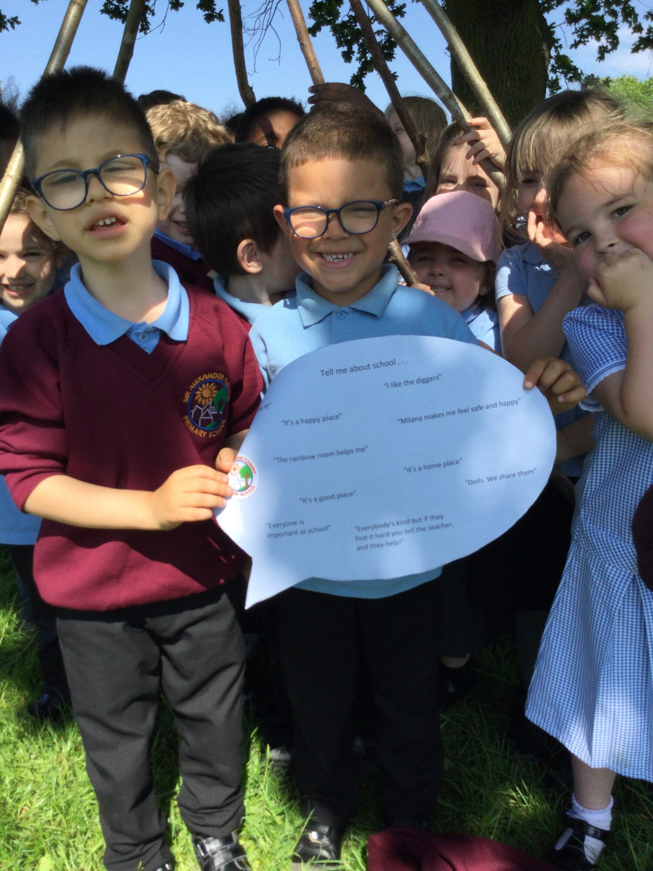

What staff say about our school…

“Having recently joined the school, it was clear from day one that this is not a ‘normal school’ to work in. The things Sir Alexander Fleming offer (including support for families, SEND provision, sporting opportunities, theatre trips, PE/Outdoor Learning teachers, residentials, TA support) are second to none and make a real difference to the children who come here. I am very glad I work here!”

Jake Andrews

“Our school offer so many exciting opportunities for our children, so much so I moved my own child to SAF after I had worked here for 1 year. He loves it here.”

Lisa Pigg

“As a relatively new member to the team, I have found the staff at Sir Alexander Fleming Primary School to be incredibly friendly, welcoming, and supportive. Everyone makes the time to listen, share ideas and answer questions. They effortlessly create an inclusive environment from the second you join the team and even from the first walk around prior to applying.

What has amazed me most about the school are the sheer quantity of resources and opportunities that we provide for the children in our care. The school goes above and beyond what I have previously experienced, and everyone truly has the best interests of the children at heart.”

Emma Robson

“Working here is rarely the same, day in, day out. Staff roles are always changing, to coincide with what the children need. The school is always looking at new ways to provide new experiences for the children, and ways to give them the emotional or academic support that they need.  The roles can be really challenging, but they are so, so rewarding.”

Nat Evans

“As teachers in the Early Years we watch the children in their journey through school. They build on their learning. They have outstanding experiences. They have the support they need, due to the skill and knowledge of staff. They graduate as respectful, safe, brave, successful young people who deserve to be proud of themselves.”

Lola Lancett

“I love that staff at Alexander Fleming are welcoming to all and you can notice this as soon as you join. You may start here shy & nervous, but before you know it you are amongst the staffrooms chatter because everyone is so friendly. We genuinely care about one another and there's not a day that goes by where someone isn't checking in on you. Knowing you have supporting people around you, whether it is for work or personal reasons, makes such a difference.”

Stef King

“What has blown me away whilst working at Alexander Fleming is the inclusivity offered due to the diverse range of staff and their skills. All pupils have the opportunity and resources to succeed. Every child matters and this is evident through the day-to-day operations of the school.”

Tom Johnson

“We as a staff work hard to promote and encourage our children daily to uphold the morals and values our school holds. We show respect to one another, we share in each others successes and work together to rise again if we fail. Our children are supported from their first day in our school and we as staff adapt and mould what we believe will benefit them and their right to a good and inclusive education.”

Isobel Brown

“As a new employee, I was immediately made to feel at home, I always had support from my coworkers, and they were always willing to provide a hand. The school values the students and provide them with a wide range of resources to help them excel in all facets of life.”

Danniella Garrett

The most nurturing, supportive staff who provide the children with knowledge, love and inspiration. A challenging environment where everybody makes a huge difference to the lives of the children and families.

Kate Casswell

Wellbeing

Staff wellbeing is taken very seriously at Sir Alexander Fleming. We believe this is essential to attract and retain staff who are highly skilled and passionate about education. At SAF, we have a team of people who support staff wellbeing and mental health. This is led by a trained Senior Mental Health Lead.

We are also committed to reducing workload and regularly review policies, systems and processes to find ways to do this. We have an open-door policy and value staff feedback and ideas about how this can be done.

What wellbeing looks like at SAF:

• Supportive, friendly and caring staff who have positive relationships

• Senior Leaders operate an open-door policy – a member of SLT is available to staff at all times

• Access to a wellbeing team including a trained Senior Mental Health Leader

• Regular collection of staff voice and sharing of how feedback has been taken on board

• Consideration people’s preferences with year groups

• Support for life events

• Domestic Abuse Policy for staff

• Signposting for help and support

• Referrals to occupational health where needed

• Discretionary time for appointments

• Time off for requested special events e.g. children’s performances

• Wellbeing Days to be used throughout the year for personal reasons.

Safeguarding

Sir Alexander Fleming Primary School and Nursery is committed to safeguarding and promoting the welfare of children and young people and expects all staff and volunteers to share in this commitment.

Appointment to this post is subject to an enhanced Disclosure and Barring Service check as well as other pre-appointment checks outlined in Keeping Children Safe in Education (September 2023).

This post may also require checks under the Childcare Disqualification Regulations and Childcare Act 2006 as you may be required to work with children in the EYFS.

Please see the job description, person specification, safer recruitment and CP and Safeguarding policies for further details.



[Policies – Sir Alexander Fleming Primary School](https://siralexanderflemingprimaryschool.org.uk/home/key-info/policies/)

Is Sir Alexander Fleming for you…

We can offer you:   
• A diverse school community with a focus of inclusivity at its heart   
• A strong school ethos that encourages positive attitudes to learning and behaviour.   
• A warm and welcoming environment to work in  
• Strong relationships across and throughout the school  
• The opportunity to strengthen links with our parents/carers and wider community.   
• An enthusiastic and committed team of staff that strive for the best outcomes for all pupils   
• Caring and enthusiastic pupils who are motivated to learn and thrive   
• A commitment to supporting your wellbeing   
  
We are looking for someone who:  
 • Can provide children with a sense of belonging by building trusting relationships in which all children are held with unconditional positive regard   
• Has a passion for inclusion and demonstrates high levels of inclusivity within working practice and actively seek to remove barriers to learning   
• Demonstrates high levels of respect for themselves, others, and the environment   
• Values diversity and promotes equality through their words, actions, and practice   
• Promotes the welfare of children and has a commitment to developing their understanding of safeguarding and their responsibilities within it   
• Makes children feel safe and secure by responding to them calmly and consistently, with warmth, care and empathy   
• Reflects on their practice and is committed to their continued professional development   
• Takes pride in and responsibility for their work and development   
• Demonstrates a positive, solution-focused attitude with high levels of resilience   
• Has excellent organisational skills   
• Be able to plan and adapt learning experiences to meet individual needs.   
• Have a passion for improving life outcomes for children from a disadvantaged background