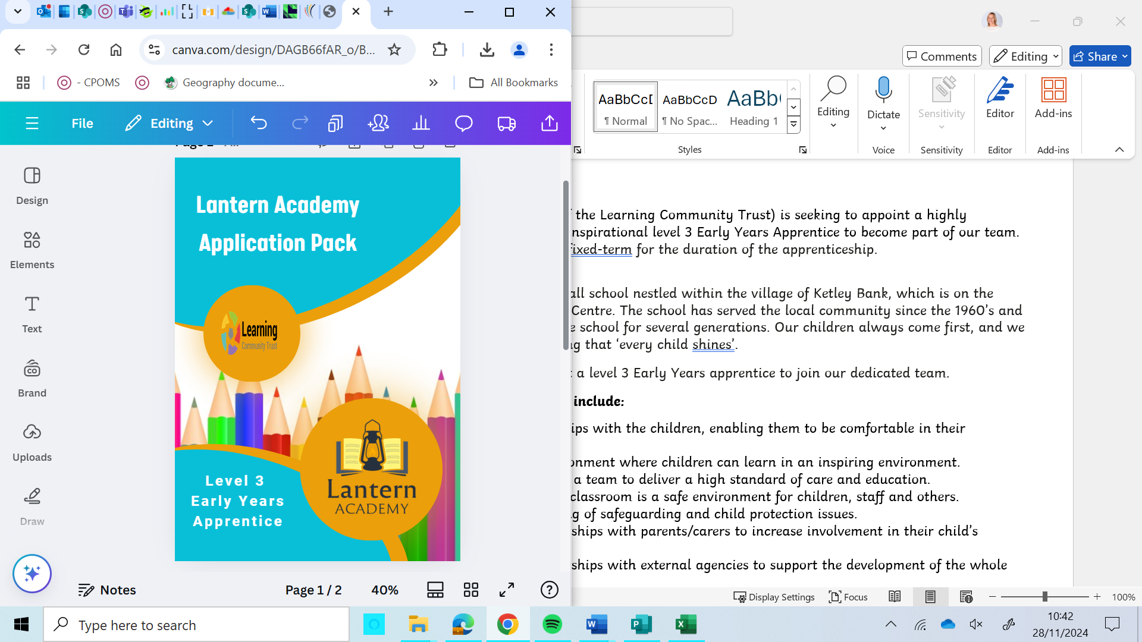

Lantern Academy (part of the Learning Community Trust) is seeking to appoint a highly motivated, dynamic and inspirational level 3 Early Years Apprentice to become part of our team.

The post is full-time and fixed-term for the duration of the apprenticeship.

Lantern Academy is a small school nestled within the village of Ketley Bank, which is on the outskirts of Telford Town Centre. The school has served the local community since the 1960’s and families have attended the school for several generations. Our children always come first, and we pride ourselves on ensuring that ‘every child shines’.

We are looking to appoint a level 3 Early Years apprentice to join our dedicated team.

**Your responsibilities will include:**

* Forming relationships with the children, enabling them to be comfortable in their surroundings.
* Providing an environment where children can learn in an inspiring environment.
* Working as part of a team to deliver a high standard of care and education.
* To ensure that the classroom is a safe environment for children, staff and others.
* Good understanding of safeguarding and child protection issues.
* Developing partnerships with parents/carers to increase involvement in their child’s development.
* Developing partnerships with external agencies to support the development of the whole child.
* Ensuring professionalism at all times in relation to confidentiality, reliability, punctuality and behaviour.
* Following instructions and taking guidance to support own development within the academy setting.
* To be responsible for any tasks delegated by the school leadership team.
* To provide a safe, caring, stimulating educational environment, both indoors and outdoors, at all times.
* To help ensure the classroom meets Ofsted requirements at all times.
* To work with other professionals in the local area for the benefit of children and families.
* To understand and work to the academy policies and procedures, including how to deal with child protection issues appropriately and how to respond to incidents, accidents, complaints and emergencies.
* To ensure records are properly maintained, e.g. daily attendance register, accident and incident book, risk assessments.
* To liaise closely with parents/carers, informing them about the curriculum, exchanging information about children’s progress and encouraging parents’ involvement.
* To undertake any other reasonable duties as directed, in accordance with the preschool aims and objectives.

We welcome and encourage informal visits, so if you are interested in joining us please contact one of the Office Administrators by telephoning the academy on 01952 386961 or emailing [lantern.academy@lct.education](mailto:lantern.academy@lct.education)

**Closing date for application:** Friday 13th December 2024

**Short listing** will take place on: Soon after

**Interviews** TBC

**Starting Date:** January 2025

**Lantern Academy Job Description**

**Job title:** Level 3 Early Years Apprentice

**Salary Range**: National Minimum Wage

**Contract: Temporary for the length of the apprenticeship**. Full year, 37 hours per week

**Line of responsibility:** Responsible to Headteacher

**Our Values:**

We Respect, We Care, We Persevere – we believe that if children adhere to these values they will have the elements required to be successful in our academy and when they move on to the next chapter of their education.

We expect our staff to: deliver high-quality performance for our children, have a positive and proactive approach, be passionate about learning and CPD; listen to and work collaboratively with others and engage in academy and Trust life

**Key purpose:**

To contribute to a happy and safe classroom for children, staff and others. To deliver challenging and enjoyable learning activities. To form positive relationships with the children, enabling them to be comfortable in their surroundings and providing an environment where they can be inspired, learn and explore. Working collaboratively with other agencies and professionals. Developing partnerships with parents/carers to increase involvement in their child’s development.

**Accountabilities:**

The appointee will work within the setting as a member of the support staff team.

The headteacher will hold the post holder to account

**Key responsibilities and activities:**

* Forming relationships with the children, enabling them to be comfortable in their surroundings.
* Providing an environment where children can learn in an inspiring environment.
* Working as part of a team to deliver a high standard of care and education.
* To ensure that the classroom is a safe environment for children, staff and others.
* Good understanding of safeguarding and child protection issues.
* Developing partnerships with parents/carers to increase involvement in their child’s development.
* Developing partnerships with external agencies to support the development of the whole child.
* Ensuring professionalism at all times in relation to confidentiality, reliability, punctuality and behaviour.
* Following instructions and taking guidance to support own development within the academy setting.
* To be responsible for any tasks delegated by the school leadership team.
* To provide a safe, caring, stimulating educational environment, both indoors and outdoors, at all times.
* To help ensure the classroom meets Ofsted requirements at all times.
* To work with other professionals in the local area for the benefit of children and families.
* To understand and work to the academy policies and procedures, including how to deal with child protection issues appropriately and how to respond to incidents, accidents, complaints and emergencies.
* To ensure records are properly maintained, e.g. daily attendance register, accident and incident book, risk assessments.
* To liaise closely with parents/carers, informing them about the curriculum, exchanging information about children’s progress and encouraging parents’ involvement.
* To undertake any other reasonable duties as directed, in accordance with the preschool aims and objectives.

**Generic Responsibilities**

* To undertake any further training as identified in the Trust review procedures.
* Ensure that safe working practices are followed in respect of COSHH and other Risk Assessment control measures. Employees must comply with the provisions of ‘The Health and Safety at Work Act 1974’ and must take reasonable care for the health and safety of themselves and of other persons who may be affected by their acts of omissions whilst at work. Employees are also required to cooperate with their employer to enable them to perform or comply with any statutory provisions. The Trust’s efforts to promote a safe and healthy working environment can only succeed with the full co-operation of its employees.
* To understand, comply with and promote the Trust’s safeguarding policy and procedures. It is the responsibility of all employees to make the working environment safe and secure for all. The Trust can only ensure its dedication to the protection of vulnerable people with the full cooperation of its employees.
* The Trust has an Equality and Diversity Policy and it is the responsibility of all staff to comply with this. The key responsibilities for staff under this Policy are set out in the Trust Code of Conduct.
* To maintain the confidentiality about clients, staff and other Trust business. The work is of a confidential nature and information gained must not be communicated to other persons except in the recognised course of duty. The post holder must meet the requirements of the Data Protection Act at all times.
* Be aware of, promote and implement the Trust’s Quality and Information Security Management Systems.
* To report to line manager, or other appropriate person, in the event of awareness of bad practice.

This job description is intended to provide a broad outline of the accountabilities and responsibilities only. The post holder will need to be flexible in developing the role in conjunction with the line manager. The post holder may be asked to carry out any other delegated duty or task that is in line with their post.

**Principal Contacts**

Pupils, parents, visitors, teachers, other school support staff.

The academy reserves the right to alter the content of this Job Description, after consultation, to reflect changes to the job or services provided, without altering the general character or level of responsibility.

The duties described in this Job Description must be carried out in a manner which promotes equality of opportunity, dignity and due respect for all employees and service users and is consistent with the academy’s Equal Opportunities Policy and Code of Conduct.

|  |  |
| --- | --- |
| **Essential** | **Desirable** |
| **Skills, aptitude, knowledge and experience**   * Ability to work independently using own initiative. * Ability to relate well to children and adults including other professionals/carers/parents * Ability to demonstrate and promote good practice in line with the ethos of the school both indoors and outdoors. * Ability to manage multiple tasks, whilst ensuring children, colleagues, parents and carers are respected and listened to. * Fluent English speaker * Effectively communicate with adults and children * Good written, verbal and non-verbal communication | * Experience of working with children * Experience of working as part of a team |
| **Personal Qualities**   * Enthusiasm for learning and working with children * Growth mindset and resilience * Positive attitude towards learning and developing * Caring, friendly, approachable, open, inclusive, welcoming, and personable * Able to maintain confidentiality at all times * Able to be professional at all times * The want to work with children and make a positive difference to their lives |  |
| **Qualifications**   * Willingness to participate in other development and training opportunities * Relevant Level 2 qualification or equivalent * GCSE English and Maths at level 4 or above |  |