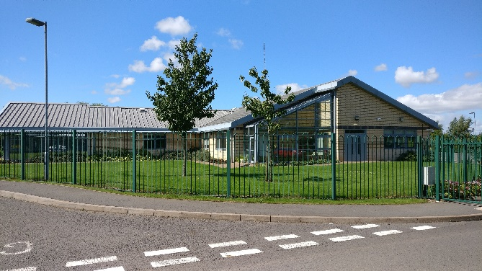

**Julie Bravo**

**Queensway Academy**

Hair & Beauty Tutor

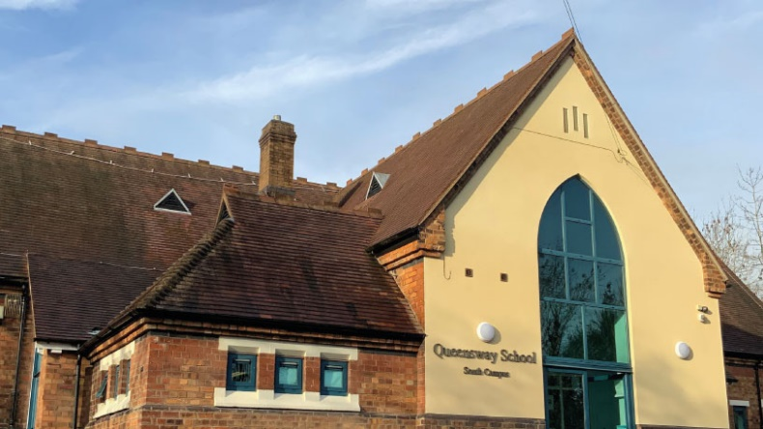



**QUEENSWAY SCHOOL**

**Hair & Beauty Tutor**

**Salary: Scale 3 (Point 5/6)**

**Dependent on experience/qualifications**

**Term time only + 1 week**

**37 hours per week – Monday to Friday**

*12-month contract*

*(in the first instance - to be reviewed)*

We are seeking to appoint a Hair & Beauty Tutor to join our school. It is a fantastic opportunity to join an established team that has excelled in so many areas, in a leading specialist setting within the region.

This post is suitable for both candidates who have worked in a school or further education and have experience in delivering hair & beauty qualifications to students. This is an exciting opportunity for a dynamic, ambitious and energetic individual who will be working with our skilful team of specialised teachers. The successful candidate will lead the hair and beauty curriculum across the school, whilst supporting other students and classes, gaining valuable experience as a teaching assistant in other subject areas.

This position will involve working with both SEMH and ASD students.

**Queensway School**

Queensway was established as an academy in March 2018 when it became part of the Learning Community Trust. It was the result of a merger of an autistic provision which had previously been linked to HLC Secondary and a SEMH school that required a sponsor and a new start. All of our students have an EHCP.

Queensway is across two sites – the North site in Hadley is a school for children with a diagnosis of Autism. The school has a PAN of 60 but due to demand for places always has additional students. It is a modern purpose, self-contained building on a lovely site with sensory and quiet rooms as well as a Sports Hall and good outdoor spaces. Queensway North has achieved the Autism Accreditation Kite mark from the National Autistic Society and our skills and strategies are worthy of their award. The school itself then ‘leads’ on Autism training both with the Local Authority and some external organisations.

The south site, in Dawley, is for students with a primary need of SEMH. It has quiet rooms, teaching spaces and an excellent purpose-built skills centre for practical work which is where our new provisions for motor vehicle and hair and beauty are situated. Queensway South’s PAN is 54 and the other students are in Y7-11.

Both sites offer an extensive curriculum which includes English, Mathematics, Science, Design Technology, Art and Physical Education, Creative iMedia, Engineering, Forest Schools Motor Vehicle, Hair and Beauty, Duke of Edinburgh and Photography. We have newly introduced Independent Living and Life Skills. Social skills/education permeates through the curriculum on both sites preparing our students for life as young adults.

All students are encouraged to take a range of examinations which best meet their needs from the differentiated curriculum which is individually designed by the experienced staff team. The outcomes have improved year on year and in 2022 over 90% of students gained five or more GCSEs at Grade 1-9 including English and Maths which was a significant achievement.

Both sites have their individual teaching teams, support staff and highly experienced Pastoral leads who also lead on safeguarding. We are fully staffed but are exploring different staffing models to support the children, the new Headteacher appointed in September 2020 will lead on this.

Queensway prides itself on its close working relationships with parents and good communications between home and school happen on a daily basis.

You will join a Trust steeped in a culture of wanting the very best for our children and is very ambitious for its schools. As a school, you will be joining a community that will do anything to make their children’s lives successful whilst preparing them for the next steps in their lives.

For more information, have a look at our website [www.queensway.school](http://www.queensway.school)

**Learning Community Trust**

We are very proud to be a part of the LCT. The expertise and skills the staff have across the trust is invaluable in sharing best practice and our experience in working with children and young people with SEND is greatly valued in our mainstream schools. We are the only provision in Telford and Wrekin for students with these needs, all our young people have an EHC plan and we work with the LA over admissions.

The LCT mission is very simple; we are driven to be an outstanding MAT for our community with a clear vision to provide the best possible education for all the children and young people in our Trust, helping them to be successful in all they do both now and in the future.

The Learning Community Trust was established in June 2017 following agreement with the DfE/RSC to establish a MAT in this community. Not only were we approved as a MAT but we are also an academy sponsor.

We keep our aims at the forefront of all we do, they represent our values as well as our intentions:

* To focus, across our schools, on **excellence** by achieving the best possible educational outcomes for our children and students by engaging and inspiring them, building their resilience and preparing them for work and adult life.
* To drive a **collaborative culture** across our schools which drives and supports improvement and develops all our staff as leading professionals
* To provide the highest levels of **care and support** for our children so they can succeed, including those that are the most disadvantaged, vulnerable or with special needs in our community
* To ensure our schools are at the heart of the community they serve and are truly **inclusive** organisations with equality for all across our community
* To engage positively with our families and wider **community**, building partnerships and programmes that develop opportunities beyond the school sector.

We have four strategic objectives which drive our work:

1. Our learners are engaged and successful
2. We have high quality staff across our Trust
3. We have a culture of continuous improvement
4. Our leadership and Governance is exemplary

For more information on Learning Community Trust, please have a look at the website <https://learningcommunitytrust.co.uk>

Julie Bravo

Headteacher

Queensway School

*The Learning Community Trust is committed to safeguarding and promoting the welfare of children and young people. All post holders working in regulated activity with children, are required to have an enhanced DBS check (including a check on the children’s barred list).*

*References will be required for all shortlisted candidates, prior to interview and these will be checked following the Learning Community Trust recruitment and selection process.  In line with the Statutory Guidance Keeping Children Safe in Education an online check will also be undertaken for all shortlisted candidates prior to the interview. Shortlisted candidates will also be required to complete a criminal self-disclosure declaration, posts that involve working in regulated activity are exempt from the Rehabilitation of Offenders Act, please note it is a criminal offence for individuals on the barred list for children to apply for any post working with children. For more information, please refer to The MOJ’s guidance on the Rehabilitation of Offenders Act 1974 and the Exceptions Order 1975, for information about which convictions must be declared during job applications and related exceptions and further information about filtering offences can be found in the DBS filtering guide.*

*We are committed to equality and diversity and follow the Safer Recruitment practices as set out in the Statutory Guidance - Keeping Children Safe in Education. For more information regarding our school’s commitment to safeguarding, please see our Child Protection & Safeguarding Policy available on our website: www.queensway.school*

|  |  |  |
| --- | --- | --- |
|  | **JOB DESCRIPTION**  **Hair & Beauty Tutor**  **Queensway School**  **part of the**  **Learning Community Trust**  **Salary Range: Scale 3 SCP5 – SCP6**  **37 hours per week term time only + 1 week**  **Actual Salary £21,228 to £21,565**  *12 month contract in the first instance to be reviewed* | **C:\Users\veronica.croft\AppData\Local\Microsoft\Windows\INetCache\Content.Outlook\5O6ZN21T\Learning Community Trust Logos-02.png** |
| Background:  Queensway School is part of the Learning Community Trust, and we are looking to appoint an enthusiastic and experienced Hair & Beauty Tutor. This is a specialist provision for young people with an EHCP with a primary need of either Social, Emotional and Mental Health or a diagnosis of ASC.  Currently we are over-subscribed and have 129 students (Y6-Y11) on roll (69 at North Campus and 60 at South), who are taught by a team of specialist teachers and support staff. Students are in small classes of 6/8 students to support their learning, and the model is of a teacher plus teaching assistant in each class. | | |
| We are seeking to appoint a Hair & Beauty Tutor to join our school. It is a fantastic opportunity to join an established team that has excelled in so many areas, in a leading specialist setting within the region.  This post is suitable for candidates who have worked in a school or further education setting and have experience in delivering hair & beauty qualifications to students.  This is an exciting opportunity for a dynamic, ambitious and energetic individual who will be working with our skilful team of specialised teachers.  This position will involve working with both SEMH and ASD students, from both campuses. The key benefits to working within our school are the relationships with not only a highly supportive staff community as well as with the students, who will enthuse you to support fantastic lessons each and every day. Importantly, one of our key principles is to support your welfare, and as part of this we offer a comprehensive Employee Assistance Program. | | |

|  |
| --- |
| Title of post  Hair & Beauty Tutor  South Campus  Salary scale  Scale 3  Actual Salary £21,228 to £21,565  Point on scale.  5-6 |
| Contracted working weeks.  Term time + 1 week  Hours per week  37 hours  Daily working hours  Monday 8.30am – 3.45pm  Tuesday 8.30am – 4.00pm  Wednesday 8.30am – 4.45pm  Thursday 8.30am – 4.00pm  Friday 8.30am – 3.00pm |
| General duties and responsibilities   * Model expectations within the classroom, stretching and challenging all pupils with an awareness of their needs and ability, in a safe and stimulating environment. * Ensure pupils secure positive outcomes through careful planning around current attainment levels. * Have a clear knowledge and experience of the hair and beauty sector, whilst feeling confident in supporting literacy and numeracy skills. * Design an engaging curriculum for hair & beauty, which meets the needs of all learners, reflecting on pupil progress and the effectiveness of lesson delivery. * Lead the Hair & Beauty alternative provision Queensway offer, delivering to mainstream referral students. * Differentiate learning content to ensure all learners can access and achieve positive outcomes, with a key focus on EHCP targets. * Use of the marking system to ensure pupils are assessed effectively, show confidence in using assessment data and report progress accurately. * Build positive relationships with students, maintain high expectations for behaviour and manage classes effectively. * Plan, assess and report to leaders and stakeholders on the progress of students attending the hair & beauty programme at Queensway. * Support classrooms and small groups of students in various programmes of study. * Follow Queensway protocols and systems which support the operational running of the school day. * Make a positive impact on the wider ethos of the school community. * Engage in the whole school CPD programme and developing knowledge around SEND practice. |

|  |
| --- |
| Line manager (also responsible for appraisal)  Deputy Head Queensway South |
| Review arrangements.  This document will be reviewed following end of year appraisal reviews and in conjunction the arrangements stated in the campus policy. However, either party may raise issues at any time that is appropriate. |
| **Next Steps**  If you require further information, to arrange a visit to the school and informal discussions please contact Mrs Sara Millward – PA to Principal/Office Manager at Queensway School on: 01952 388555  Closing date for applications: **Thursday 23rd January 2025**  Interviews: **Monday 27th January 2025**  Please email your application form and any supporting documentation to: [Sara.Millward1@lct.education](mailto:Sara.Millward1@lct.education) |

Signed………………………………………………… (Post Holder)

Signed …………………………………………………(Headteacher)

Date……………………………………….

An electronic copy of this document will be kept with your personnel records.